

EVIDENCE-BASED RESOURCE GUIDE SERIES

Treatment for Suicidal Ideation, Self-Harm, and Suicide Attempts Among Youth

Treatment for Suicidal Ideation, Self-Harm, and Suicide Attempts Among Youths
Acknowledgments
This report was prepared for the Substance Abuse and Mental Health Services Administration (SAMHSA) under contract number HHSS283201700001/ 75S20319F42002 with SAMHSA. Donelle Johnson served as the contracting officer representative.
Disclaimer
The views, opinions, and content of this publication are those of the authors and do not necessarily reflect the views, opinions, or policies of SAMHSA. Nothing in this document constitutes a direct or indirect endorsement by SAMHSA of any non-federal entity’s products, services, or policies, and any reference to non-federal entity’s products, services, or policies should not be construed as such.
Public Domain Notice
All material appearing in this publication is in the public domain and may be reproduced or copied without permission from SAMHSA. Citation of the source is appreciated. However, this publication may not be reproduced or distributed for a fee without the specific, written authorization of the Office of Communications, SAMHSA.
Electronic Access
This publication may be downloaded from http://store.samhsa.gov
Recommended Citation
Substance Abuse and Mental Health Services Administration (SAMHSA): Treatment for Suicidal Ideation, Self-harm, and Suicide Attempts Among Youth. SAMHSA Publication No. PEP20-06-01-002 Rockville, MD: National Mental Health and Substance Use Policy Laboratory. Substance Abuse and Mental Health Services Administration, 2020.
Originating Office
National Mental Health and Substance Use Policy Laboratory, Substance Abuse and Mental Health Services Administration, 5600 Fishers Lane, Rockville, MD 20857, SAMHSA Publication No. PEP20-06-01-002.
Nondiscrimination Notice
SAMHSA complies with applicable federal civil rights laws and does not discriminate on the basis of race, color, national origin, age, disability, or sex.
SAMHSA cumple con las leyes federales de derechos civiles aplicables y no discrimina por motivos de raza, color, nacionalidad, ni edad.
Publication No. PEP20-06-01-002 Released 2020

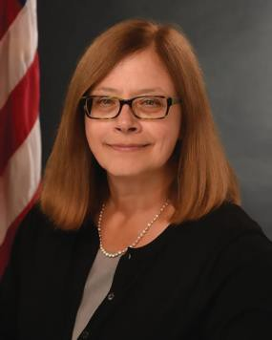
MESSAGE FROM THE ASSISTANT SECRETARY FOR MENTAL HEALTH AND SUBSTANCE USE,
U.S. DEPARTMENT OF HEALTH AND HUMAN SERVICES

As the U.S. Department of Health and Human Services Assistant Secretary for Mental Health and Substance Use at the Substance Abuse and Mental Health Services Administration (SAMHSA), I am pleased to present this new resource: Treatment for Suicidal Ideation, Self-Harm, and Suicide Attempts Among Youth.
In response to the charge of the 21st Century Cures Act to disseminate information on evidence-based practices and service delivery models, the National Mental Health and Substance Use Policy Laboratory developed the Evidence-Based Resource Guide Series focused on the prevention and treatment of substance use disorders and mental illnesses. With this specific guide, SAMHSA’s goal is to inform healthcare professionals, healthcare system administrators, teachers and school administrators, parents, community members, policy makers, and others of the strategies for treating suicidal ideation, self-harm, and suicide attempts among youth.
Suicide is the second leading cause of death for youth in the United States. The suicide rate for youth aged 10 to 24 increased 56 percent from 6.8 per 100,000 in 2007 to 10.6 per 100,000 in 2017.¹ Many factors contribute to thoughts of suicide in this population, including depression, hopelessness, low self-esteem, peer and parental relationship problems, academic difficulties, and substance use. Suicide is preventable, suicidal thoughts and behaviors are treatable, and interventions are available and should be accessible to any young person who needs help.
This guide discusses the prevalence of suicide among youth, effective treatment programs, implementation considerations and strategies, and examples of the successful use of programs in clinical and community- based settings. I encourage you to use this guide to identify treatment programs you can implement to address suicidal ideation, self-harm, and suicide attempts among youth in your communities.

Elinore F. McCance-Katz, MD, PhD
Assistant Secretary for Mental Health and Substance Use
U.S. Department of Health and Human Services

1 Curtin, S. C. & Heron, M. (2019). Death rates due to suicide and homicide among persons aged 10-24: United States, 2000-2017. National Center for Health Statistics, Centers for Disease Control and Prevention. https://www.cdc.gov/nchs/data/databriefs/db352-h.pdf.

Evidence-Based Resource Guide Series Overview

The Substance Abuse and Mental Health Services Administration (SAMHSA), and specifically, its National Mental Health and Substance Use Policy Laboratory (Policy Lab), is pleased to fulfill the charge of the 21st Century Cures Act to disseminate information on evidence-based practices and service delivery models to prevent substance misuse and help people with substance use disorders (SUD), serious mental illnesses (SMI), and serious emotional disturbances (SED) get the treatment and support they need.
Treatment and recovery for SUD, SMI, and SED can vary based on several geographic, socio-economic, cultural, gender, race, ethnicity, and age-related factors which can complicate evaluating the effectiveness
of services, treatments, and supports. Despite these variations, however, there is substantial evidence to inform the types of resources that can help reduce substance use, lessen symptoms of mental illness, and improve quality of life.
The Evidence-Based Resource Guide Series is a comprehensive set of modules with resources to improve health outcomes for people at risk for, with, or recovering from mental and/or substance use
disorders. It is designed for practitioners, administrators, community leaders, and others considering an intervention for their organization or community.
A priority topic for SAMHSA is ensuring the availability of effective treatment for youth with suicidal ideation
or who have attempted suicide or engaged in self-harm. This guide reviews the related literature and science, examines emerging and best practices, identifies gaps in knowledge, and discusses challenges and strategies for implementation.
Expert panels of federal, state, and non-governmental participants provide input for each guide in this series. The panels include accomplished scientists, researchers, service providers, community administrators, federal and state policy makers, and people with lived experience.
Members provide input based on their knowledge of healthcare systems, implementation strategies, evidence- based practices, provision of services, and policies that foster change.
Research shows that implementing new programs and practices requires a comprehensive, multi-pronged approach. This guide is one piece of an overall approach to implement and sustain change. Users are encouraged to review the SAMHSA website for additional tools and technical assistance opportunities.

FOREWORD

Content of the Guide
This guide contains a foreword and five chapters. The chapters stand alone and do not need to be read in order. Each chapter is designed to be brief and
accessible to healthcare providers, healthcare system administrators, community members, policy makers, and others working to meet the needs of individuals
at risk for, experiencing, or recovering from mental and/or substance use disorders.
The goal of this guide is to review the literature on treatment for suicidal ideation, self-harm, and suicide attempts among youth, distill the research into recommendations for practice, and provide examples of how practitioners can use these practices in their programs. The programs included in this
guide focus on adolescents and young adults who are currently experiencing suicidal ideation, self-harm, and/or suicide attempts, and addresses risk factors unique to this population. The programs can be implemented by mental health professionals in a variety of settings, including schools, community mental health centers, residential facilities, or juvenile justice programs.
FW Evidence-Based Resource Guide Series Overview
Introduction to the series.
- Issue Brief
Overview of current approaches and challenges to addressing suicidal ideation, self-harm, and suicide attempts among youth.
- What Research Tells Us
Current evidence on effectiveness of the following programs included in the guide to treat suicidal ideation, self-harm, and suicide attempts among youth: Dialectical Behavior Therapy and Attachment-Based Family Therapy.
- Guidance for Selecting and Implementing Evidence-Based Programs
Practical information to consider when selecting and implementing programs and practices to treat suicidal ideation, self-harm, and suicide attempts among youth.
- Examples of Suicide Treatment Programs
Examples of programs to treat suicidal ideation, self-harm, and suicide attempts among youth.
- Resources for Evaluation and Quality Improvement
Guidance and resources for implementing programs and practices, monitoring outcomes, and improving quality.

FOCUS OF THE GUIDE
Suicide is the second leading cause of death for youth and young adults in the United States. Factors contributing to thoughts of suicide in this population include mental
health and substance use problems, low self-esteem, peer and parental relationship problems, and academic difficulties.
Suicidal ideation, self-harm, and suicide attempts are higher among youth than adults. Approximately 17 percent of high school students
reported suicidal ideation in the past year, and 7.4 percent of high school students reported a suicide attempt in the same period. The prevalence of suicidal thoughts and behaviors is higher in some groups, including
LGBTQ+ youth and racial and ethnic minorities, particularly American Indian and Alaska Native youth and youth of more than one race.
This guide presents programs and practices that address effective treatment of suicidal thoughts, suicidal behaviors, and self-harm among youth and young adults.
Interventions need to be part of a comprehensive approach that seeks to decrease suicide risk factors
and increase protective factors.
In addition, systemic barriers to effective treatment for youth need to be addressed, including appropriate referrals and linkage to treatment services, improved education and training for healthcare professionals, and increased availability of services and insurance coverage for diagnosis and treatment of mental disorders and suicidal behaviors.

The framework below provides an overview of this guide. The review of treatment programs in Chapter 2 of the guide includes specific outcomes, practitioner types, and delivery settings for the programs.
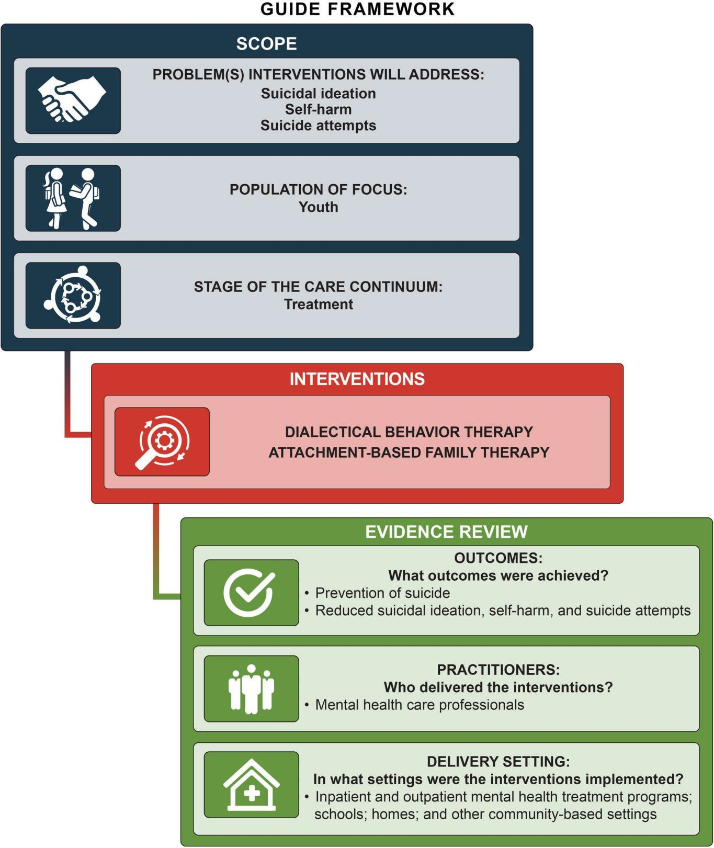

CHAPTER
Suicide is now the second leading cause of death for adolescents and young adults aged 15 to 24 in the United States,1 and suicide attempts are significantly higher among youth, compared to adults.2-3
1

Issue Brief

Suicide, suicide attempts, self-harm, and suicidal ideation are significant public health concerns in young people.
Suicide is now the second leading cause of death for adolescents and young adults aged 15 to 24 in the United States,¹ and suicide attempts are significantly higher among youth, compared to adults.²⁻³ Suicidal ideation,self- harm, and suicide attempts are more common than suicide death in young people, and are associated with several other negative consequences, such as co-morbid mental disorders, poor educational and vocational outcomes, and premature death due to other causes.⁴ Studies show that people who attempt suicide in adolescence have a higher likelihood of mental health treatment utilization, mental illness diagnosis, and adult suicide.⁵
The impacts of youth suicide extend beyond the individual. Research indicates exposure to a suicide (e.g., schoolmate’s suicide and personally knowing someone who died by suicide) predicts suicide ideation and attempts.⁶ The National Longitudinal Survey
of Adolescent Health reveals that for the first year following a friend’s death by suicide, peers experience heightened suicidal ideation and attempts, as well as higher rates of depression.⁷

What is Suicide?
Suicide is a death caused by self-directed injurious behavior with any intent to die as a result of the behavior.⁸
A suicide attempt is a non-fatal, self-directed, and potentially injurious behavior with any intent to die as a result of the behavior.⁸ Previous suicide attempts
significantly increase a youth’s risk of death by suicide⁹ and often lead to subsequent and more lethal suicide attempts.¹⁰

Suicide contagion is a process where exposure to the suicide or suicidal behaviors of others influences people who are already vulnerable and considering suicide. Exposure to suicide by a close friend, family member, or another person within one’s social network is considered a significant suicide risk factor for individuals and communities.11
Suicidal ideation refers to thinking about or planning suicide. The thoughts lie on a continuum of severity from a wish to die with no method, plan, intent, or behavior, to active suicidal ideation with a specific plan and intent.¹² Although suicidal ideation does not include physically harmful behaviors, over one third of adolescents who experience suicidal ideation will attempt suicide within their lifetimes.¹³
Self-harm is behavior that is self-directed and deliberately results in injury or the potential for injury to oneself.⁸ The term, also referred to as self-directed violence, encompasses both suicidal and non-suicidal self-injury (NSSI), and
self-harm with unclear intent. NSSI is distinguished from a suicide attempt or suicide because it does not include
suicidal intent.¹⁴ NSSI is considered a significant risk factor for both suicide attempts and death by suicide and may or may not accompany suicidal ideation.¹⁵

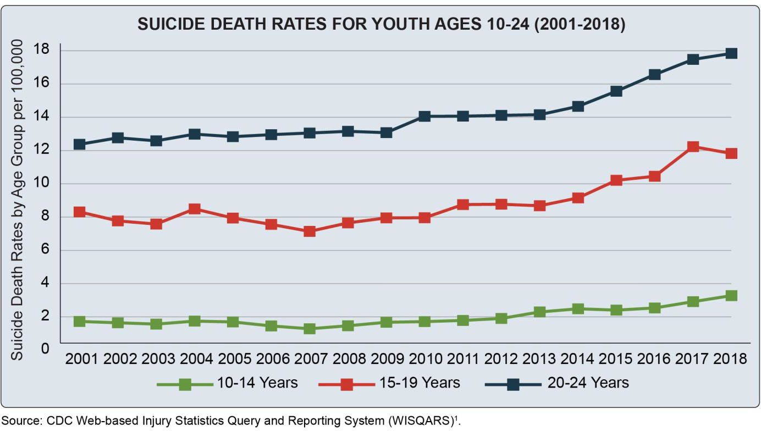

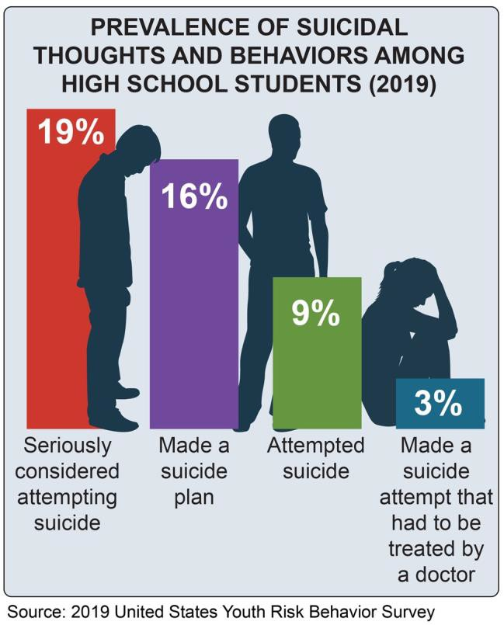
Prevalence
Source: CDC Web-based Injury Statistics Query and Reporting System (WISQARS)1 .

Source: 2019 United States Youth Risk Behavior Survey
The suicide death rate for adolescents and young adults has increased in the past two decades. In 2018, the suicide death rates for adolescents and young adults were 2.85 per 100,000 for ages 10 to 14, 11.39 per 100,000 for ages
15 to 19, and 17.4 per 100,000 for ages 20 to 24.¹ In all age groups, males have a higher suicide death rate than females. However, from 1999 through 2018, the suicide death rate doubled for females aged 15 to 19 and 20 to
- For youth aged 10 to 14, the suicide death rate more than tripled from 2001 to 2018.¹⁶⁻¹⁷ Explanations for the increase in suicide may include bullying, social isolation, increase in technology and social media, increase in mental illnesses, and economic recession.
Suicidal ideation, self-harm, and suicide attempts are significantly higher in youth compared to adults, despite adult suicide death rates being higher.^{1,3,18} In 2019, approximately 18.8 percent of high school students
reported suicidal ideation in the past year, and 8.9 percent of high school students reported a suicide attempt in
the past year.³ Rates of high school students reporting purposefully hurting themselves without wanting to die over the past 12 months ranged from 6.4 to 14.8 percent for males and 17.7 to 30.8 percent for females in 2015.¹⁹

Prevalence of suicidal thoughts and behaviors is particularly high in lesbian, gay, bisexual, transgender, and questioning or queer youth and youth with other sexual and gender minority identities (LGBTQ+).
Lesbian, gay, and bisexual adolescents and young adults are two to four times more likely to report suicidal ideation, self-harm, and a suicide attempt compared to their heterosexual peers.³ Transgender youth are four
to five times more likely to attempt suicide compared to their peers who exclusively identify as their sex assigned at birth (i.e., cisgender), with about 34.6 percent reporting a suicide attempt in the past year.²⁰ LGBTQ+ youth often experience unique stressors
related to their identity, such as discrimination, violence, trauma, expectations of rejection, concealment of their identity, and internalized homo- and trans-negativity, that increase risk for mental disorders and suicide.²¹
Some racial and ethnic minority youth also experience higher rates of suicidal behaviors. In 2017, American Indian and Alaska Native (AI/AN) youth, as well as youth of more than one race, reported the highest rates of both suicidal ideation and suicide attempts.²² While suicide attempt rates decreased among most racial and ethnic groups between 1991 and 2017, Black youth experienced an increase in suicide attempts and injury by suicide attempt.²² Differences in suicide attempt rates may be attributed to disparities in access to mental health treatment and other factors that AI/AN and Black youth disproportionally experience, including poverty,
historical trauma, and adverse childhoodexperiences.²²⁻²³

Importance of Prevention
While the primary focus of this guide is on treatment approaches, it is necessary to highlight the importance of prevention strategies in stopping young people from engaging in suicidal behaviors. This chapter provides context regarding risk and protective factors and some core prevention strategies critical to treatment program planning and implementation.

Risk and Protective Factors
Risk factors are characteristics that potentially increase an individual’s level of suicide risk, whereas protective factors are factors that mitigate against risk. Adolescents and young adults are in a state of transition, facing new independence, identity formation, and changing social situations at school and home. The significant physical, hormonal, and social changes of adolescence can increase the likelihood of a young person experiencing anxiety or depression.²⁴
Mental and substance use disorders, including depression, anxiety, bipolar disorders, eating disorders, marijuana use, and alcohol use or misuse, also increase the likelihood and severity of suicidal ideation,²⁵ as well as risk of suicide attempts²⁶ and deaths.²⁷⁻²⁸ Other individual-level risk factors include but are not limited to:
- Previous suicide attempts
- Childhood trauma, such as physical, sexual, and emotional abuse
- Being in the child welfare system
- Being a victim or perpetrator of bullying
- Experiencing a stressful event
- Consistent low-level or toxic stress
- Dysregulated sleep
- Hopelessness
- A sense of losing control
- Emotional reactivity or pattern of aggressive or aggressive-impulsive behavior
- Access to non-secure firearms
- Access to lethal means of suicide, including medications11,13,29-31
Family-level risk factors include parental depression, suicidal behavior, and substance use disorders.³²⁻³³

Marijuana use and depression are associated with suicidal ideation34 and a greater likelihood of suicide attempts among adolescents.35-36 Adolescents who use marijuana are also at increased risk of developing depression and
suicidal thoughts and behaviors later in life.37 The associations between marijuana, depression, and suicide are growing concerns. Marijuana use, marijuana use disorder, and major depressive episodes increased among adolescents aged 12 to 17 between 2016 and 2019.

The association between alcohol use and suicidal thoughts and behaviors is of concern, since more than 21 percent of youth aged 12 to 17 used alcohol in 2019, and 9.4 percent reported past month use.2

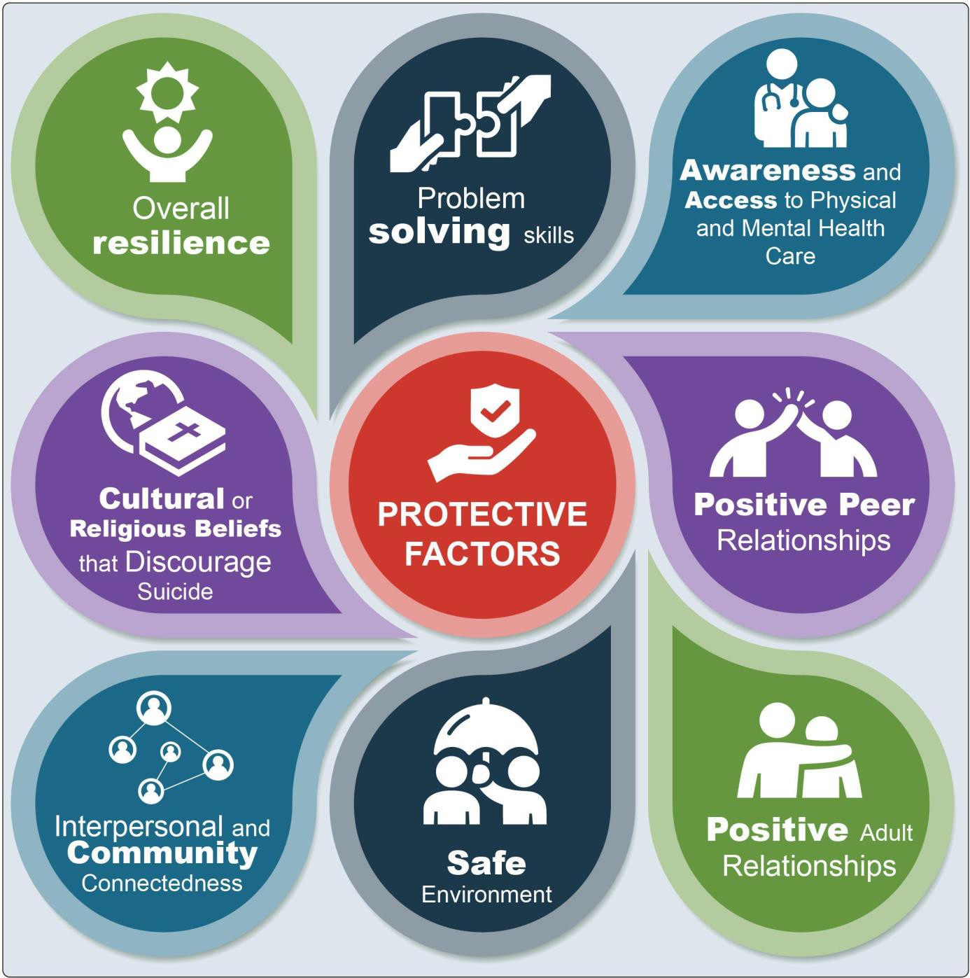

Knowledge of risk factors helps clinicians and program administrators understand chronic risks clients have.
Although single risk factors are severely limited in their ability to accurately predict suicidal thoughts and behaviors,³⁸ recent studies suggest that combinations of risk factors predict more effectively.³⁹ Nevertheless, there is considerable heterogeneity among youth at risk
for suicide, and risk levels can increase or decrease over time. Therefore, there is no one-size-fits-all approach to prevention or treatment.^{38,40}

Factors that reduce risk for suicidal thoughts, attempts, and deaths are referred to as protective factors.
Recognizing them is just as important, if not more so, as understanding factors that increase risk.⁴¹ Adolescence offers a period of developmental opportunity to discover new outlooks, form positive relationships, and explore one’s identity. It is also a period that can increase resilience when youth overcome challenges and thrive as they develop and mature.⁴²

to as intrapersonal functions, include emotional pain, hopelessness, and a desire to escape. External factors, referred to as interpersonal functions, include conflicts with parents, friends, and significant others, social pressures promoting suicide, and a desire for help from others.⁴⁶⁻⁴⁷ There can be different factors or motivations related to suicidal behavior and self-harm, but the one defining feature of the suicide attempt is at least some desire to die.

- Talking about or making plans for suicide
- Expressing hopelessness about the future
- Displaying severe/overwhelming emotional pain or distress
- Showing worrisome behavioral cues or marked changes in behavior, particularly in the presence of the warning signs above. This includes significant:
  - Withdrawal from or change in social connections/situations
  - Changes in sleep (increased or decreased)
  - Anger or hostility that seems out of character or context
  - Recent increased agitation or irritability43
For more information, visit www.youthsuicidewarningsigns.org.

A core set of suicide prevention strategies for communities and states can be found in Preventing Suicide: A Technical Package of
Policy, Programs, and Practices, developed by the Centers for Disease Control and Prevention.48

Protective factors that discourage suicide include interpersonal and community connectedness, problem solving skills, adaptability, effective clinical care for physical and mental disorders, and cultural and religious beliefs.⁴⁴ By decreasing risk factors and bolstering protective factors, youth have a better opportunity to heal, process, receive support, and grow to be healthy adults.⁴⁵ Many of the interventions reviewed in this guide focus on strengthening these and other protective factors found in the youth suicide prevention and treatmentliterature.
In addition to understanding risk and protective factors, the suicide prevention field is also moving towards a deeper understanding of the specific risks in the months, weeks, days, and hours before a suicidal event occurs. These more immediate risks are often described as suicide warning signs.

Functions Associated with Self-Harm and Suicide Attempts
Different functions and motivations underlie self-harm and suicidal thoughts and behaviors. An understanding of these functions can help inform prevention and intervention approaches. Internal motivators, referred

Prevention and Early Intervention
The 2012 National Strategy for Suicide Prevention (the National Strategy) is a call to action that is intended to guide suicide prevention actions in the United States. The National Strategy recognizes that everyone—
businesses, educators, healthcare institutions, government, communities, and individuals—has a role in preventing suicide. Prevention and early intervention policies, programs, and services are critical to addressing suicide risk factors. Population-based prevention approaches throughout childhood and adolescence have the potential to reduce youth suicide rates. These include:
- Preventing trauma and adverse childhood experiences
- Promoting parenting skills training
- Establishing good family supports
- Strengthening positive coping norms
- Implementing policies and laws that reduce binge drinking and access to lethal means
Other prevention and early interventions focus on identifying those at risk and in crisis, implementing programs in settings where at-risk youth are most likely to be, and increasing access to care. Routine screening for mental disorders and suicide risk, suicide risk and safety assessments, and gatekeeper trainings⁴⁹ allow the people most likely to encounter youth experiencing suicidal thoughts and behaviors to identify risk and respond appropriately.

FDA-Approved Medications for Children and Teenagers

Universal screening for suicide risk using a standardized tool is an essential component of a comprehensive suicide prevention program. Screening helps providers identify individuals who may be at risk and implement appropriate care plans. Suicide screening can be done independently or as part of a more comprehensive health or behavioral health screening. The Ask Suicide-Screening
Questions (ASQ), the Columbia Suicide Severity
Rating Scale (C-SSRS), and the Patient Health Questionnaire-9 Modified for Teens (PHQ-A) are all validated screening tools for use in medical and other settings for youth. A positive screen is typically followed by a comprehensive suicide risk assessment and safety planning if warranted.
Medication53-54 (common brand  name) | Age (in  years) | Diagnosis
Clomipramine (Anafranil) | 10 and older | Obsessive- compulsive disorder (OCD)
Duloxetine (Cymbalta) | 7 and older | Generalized anxiety disorder
Escitalopram (Lexapro) | 12 and older | Major depressive disorder
Fluoxetine (Prozac) | 8 and older | Major depressive disorder
Fluoxetine (Prozac) | 7 and older | OCD
Fluvoxamine | 8 and older | OCD
Olanzapine and fluoxetine, combination drug  (Symbyax) | 10 and older | Bipolar depression
Sertraline (Zoloft) | 6 and older | OCD

Schools, justice programs, healthcare systems, child welfare agencies, community-based organizations, and other settings and systems youth access can implement prevention programs and services. These can include crisis interventions that address imminent risk and connect people to services, such as hotlines or safety planning. Education and mental health awareness programs also help destigmatize mental health concerns and normalize seeking help.
The Substance Abuse and Mental Health Services Administration’s Garrett Lee Smith (GLS) Suicide Prevention and Early Intervention Grant Program provides campuses, states, and tribes support to implement comprehensive suicide prevention and early intervention strategies. The grant program has been associated with long-term, lower than expected rates of suicide attempts and deaths.⁵⁰ The GLS program emphasizes the use of
the Zero Suicide framework in youth suicide prevention efforts. The Zero Suicide framework outlines a systematic approach for suicide risk identification and care in health and behavioral health care systems and is a key tenet of the National Strategy.⁵¹

Treating Suicidal Ideation, Suicide Attempts, and Self-Harm in Youth
The National Strategy also promotes implementation of treatment interventions for those at risk for suicide. Evidence-based treatment approaches for adolescents who present with suicidal ideation or who have made

Depression and other mental illnesses in children should be treated. A treatment course often includes psychotherapy and medication.55
Medications can affect the adolescent brain differently than the adult brain.56 In 2004, the
U.S. Food and Drug Administration issued a boxed warning (also referred to as “black box warning”) indicating certain antidepressants were associated with an increased risk of suicidal ideation and behaviors in young people. For many youth experiencing depression or anxiety disorders, the benefits of antidepressants outweigh the risks. However, for others, especially those under age 25, the risk for suicide when taking antidepressant medications may be greater.57 Therefore, prescribers, clients, and their families should closely monitor for adverse behavioral changes among youth receiving antidepressant therapy in order to reduce the risk of suicidal thoughts and behaviors.56

Safety planning is a collaborative process in which an individual and provider work together to develop a personalized list of coping strategies the individual can use during times of increased suicide risk. Safety planning is brief, effective, and can be done by any health professional with training. Safety planning should be universally available for youth at risk of suicide.
Family Intervention for Suicide Prevention (FISP), also referred to as SAFETY-Acute, is a developmentally-informed safety planning intervention for youth that focuses on building hope and reasons for living, helping youth
understand their signs and patterns of emotional escalation, and identifying strategies to
stay safe. The intervention assists parents, caregivers, and other caring adults in supporting youth to use their safety plans and restrict access to dangerous suicide/self-harm methods. Caring follow-up contacts are provided until youth successfully link to needed follow-up care.52

a suicide attempt aim to reduce the frequency and intensity of suicidal ideation and prevent recurrence of self-harm behaviors and premature death. Most effective treatments are conducted by a licensed mental health professional (e.g., psychologist, psychiatrist, clinical social worker, or marriage and family therapist) and take place over multiple sessions. Treatment may occur in
a variety of settings, primarily as outpatient, intensive outpatient, and partial hospital programs. In some cases, treatment is initiated in an emergency department or psychiatric hospital following a suicide attempt and continues on an outpatient basis following discharge.
Interventions may primarily focus on treating suicidal thoughts and behaviors directly, but should also address self-harm as a potential symptom of one of the disorders that commonly co-occur with suicidal thoughts and behaviors (e.g., depression, borderline personality disorder). When self-harm behavior or suicide risk
is associated with a mental illness, providers need to identify that condition and modify treatment plans to specifically address the risk of suicide.

Medications that are approved for youth by the U.S. Food and Drug Administration (FDA), including antidepressants, anti-anxiety medications, stimulants, antipsychotics, and mood stabilizers, may be helpful in managing underlying mental illness. Individuals should be closely monitored for changes in thoughts of
suicide or suicidal behaviors after medications have been initiated or the medication dose is changed.
The focus of this guide is suicide treatment. Therefore, it does not review treatments or medication effectiveness for mental disorders, such as depression, that commonly co-occur with suicidal thoughts.
Clinical management of suicidal behaviors can be complex, and specific evidence-based interventions to address suicidal ideation and self-harm behaviors are often underutilized or not available. Numerous individual- and systems-level barriers to treatment for
suicidal ideation, suicide attempts, and self-harm exist.
At the individual level, many youth and families have limited knowledge of what treatment options are available and what options are considered evidence- based. Additional barriers include:
- Stigma associated with seeking help, mental illness, and suicide
- Practical barriers to engaging in treatment (e.g.,
cost, transportation, time)
- Lack of parental support for treatment
- Resistance or limited readiness and motivation to seek treatment
When individuals feel they do not have acceptable treatment options, they are less likely to engage in treatment and adhere to care plans.⁵⁸
At the systems level, noted barriers include:
- Insufficient access to evidence-based treatment
- Lack of culturally responsive treatments
- Limited transportation options (e.g., accessibility/affordability)
- Insurance limitations
- Absence of affordable treatment options⁵⁹⁻⁶⁰
Furthermore, clinicians are often uncomfortable with their skill set for treating of youth experiencing suicidal thoughts and behaviors, or are not adequately trained to address these concerns in this age group.⁶¹

Summary
Suicide is complex, and a comprehensive approach is needed to address different aspects of this preventable public health problem. Evidence-based treatment to address suicidal ideation, self-harm, and suicide attempts is one key aspect of a broader set of programs, practices, and policies that aim to decrease youth suicide risk factors and increase protective factors. Other critical elements to addressing this issue include:
- Effective suicide risk screening, assessment, referrals, and linkage to evidence-based programs
- Improved education and training for mental
health care professionals in these interventions
- Increased health insurance coverage for diagnosis and treatment of mental disorders and suicidal behaviors
This guide synthesizes and disseminates current evidence on treatment interventions for youth suicide to make it readily accessible by those on the frontlines helping youth at risk.


Reference List

¹ National Centers for Injury Prevention and Control, Centers for Disease Control and Prevention. (2018). Web-based injury statistics query and reporting system (WISQARS). www.cdc.gov/injury/wisqars
² Center for Behavioral Health Statistics and Quality, Substance Abuse and Mental Health Services Administration. (2019). Key substance use and mental health indicators in the United States: Results from the 2018 National Survey on Drug Use and Health. (HHS Publication No. PEP19-5068, NSDUH Series H-54). https://www.samhsa.gov/data/
³ Ivey-Stephenson, A. Z., Demissie, Z., Crosby, A. E., Stone, D. M., Gaylor, E., Wilkins, N., Lowry, R., & Brown, M. (2020). Suicidal Ideation and Behaviors Among High School Students — Youth Risk Behavior Survey, United States, 2019. Morbidity and Mortality Weekly Report, 68(Suppl 1), 47-
  - https://www.cdc.gov/mmwr/volumes/69/su/ su6901a6.htm
⁴ Cox, G., & Hetrick, S. (2017). Psychosocial interventions for self-harm, suicidal ideation and suicide attempt in children and young people: What? How? Who? and Where? Evidence-Based Mental Health, 20(2), 35-40. https://doi.org/10.1136/eb- 2017-102667
⁵ Brière, F. N., Rohde, P., Seeley, J. R., Klein, D., & Lewinsohn, P. M. (2015). Adolescent suicide attempts and adult adjustment. Depression and Anxiety, 32(4), 270-276. https://doi.org/10.1002/ da.22296
⁶ Swanson, S. A., & Colman, I. (2013). Association between exposure to suicide and suicidality outcomes in youth. Canadian Medical Association Journal, 185(10), 870-877. https://www.doi. org/10.1503/cmaj.121377
⁷ Feigelman, W., & Gorman, B. S. (2008). Assessing the effects of peer suicide on youth suicide. Suicide and Life-Threatening Behavior, 38(2), 181-194. https://doi.org/10.1521/suli.2008.38.2.181
⁸ Crosby, A., Ortega, L., & Melanson, C. (2011). Self- directed violence surveillance: Uniform definitions and recommended data elements, version 1.0. National Center for Injury Prevention and Control, Centers for Disease Control and Prevention. https:// stacks.cdc.gov/view/cdc/11997
⁹ Shain, B. (2016). Suicide and suicide attempts in adolescents. Pediatrics, 138(1), e20161420. https:// doi.org/10.1542/peds.2016-1420
¹⁰ Bostwick, J. M., Pabbati, C., Geske, J. R., & McKean,
A. J. (2016). Suicide attempt as a risk factor for completed suicide: Even more lethal than we knew. American Journal of Psychiatry, 173(11), 1094-1100. https://doi.org/10.1176/appi.ajp.2016.15070854
¹¹ Sullivan, E. M., Annest, J. L., Simon, T. R., Luo, F., & Dahlberg, L. L. (2015). Suicide trends among persons aged 10-24 years--United States, 1994-
2012. Morbidity and Mortality Weekly Report, 64(8), 201-205. https://www.cdc.gov/mmwr/preview/ mmwrhtml/mm6408a1.htm
¹² Posner, K., Brown, G. K., Stanley, B., Brent, D. A., Yershova, K. V., Oquendo, M. A., Currier,
G. W., Melvin, G. A., Greenhill, L., Shen, S., & Mann, J. J. (2011). The Columbia-Suicide
Severity Rating Scale: Initial validity and internal consistency findings from three multisite studies with adolescents and adults. American Journal
of Psychiatry, 168(12), 1266-1277. https://doi. org/10.1176/appi.ajp.2011.10111704
¹³ Cha, C. B., Franz, P. J., Guzmán, E. M., Glenn,
C. R., Kleiman, E. M., & Nock, M. K. (2018). Annual research review: Suicide among youth - Epidemiology, (potential) etiology, and treatment. Journal of Child Psychology and Psychiatry and Allied Disciplines, 59(4), 460-482. https://doi. org/10.1111/jcpp.12831
¹⁴ Center for Substance Abuse Treatment. (2009). Addressing suicidal thoughts and behaviors in substance abuse treatment. Treatment Improvement Protocol (TIP) Series 50. (HHS Publication No. (SMA) 09-4381). Substance Abuse and Mental Health Services Administration. https://www.ncbi. nlm.nih.gov/books/NBK64022/
¹⁵ Brown, R. C., & Plener, P. L. (2017). Non-suicidal self-injury in adolescence. Current Psychiatry Reports, 19(3), 20. https://doi.org/10.1007/s11920- 017-0767-9
¹⁶ American Academy of Child & Adolescent Psychiatry. (2018). Suicide in children and teens. Facts for Families, 10. https://www.aacap.org/ AACAP/Families_and_Youth/Facts_for_Families/ FFF-Guide/Teen-Suicide-010.aspx
¹⁷ Bauman, S., Toomey, R. B., & Walker, J. L. (2013). Associations among bullying, cyberbullying,
and suicide in high school students. Journal of Adolescence, 36(2), 341-350. https://doi. org/10.1016/j.adolescence.2012.12.001

¹⁸ Piscopo, K., Lipari, R. N., Cooney, J., & Glasheen, C. (2016). Suicidal thoughts and behavior among adults: Results from the 2015 National Survey on Drug Use and Health. National Survey on Drug Use and Health Data Review. http://www.samhsa.gov/data/
¹⁹ Monto, M. A., McRee, N., & Deryck, F. S. (2018). Nonsuicidal self-injury among a representative sample of US adolescents, 2015. American Journal of Public Health, 108(8), 1042-1048. https://doi. org/10.2105/ajph.2018.304470
²⁰ Johns, M. M., Lowry, R., Andrzejewski, J., Barrios,
L. C., Demissie, Z., McManus, T., Rasberry, C. N., Robin, L., & Underwood, J. M. (2019). Transgender identity and experiences of violence victimization, substance use, suicide risk, and sexual risk behaviors among high school students - 19 states and large urban school districts, 2017. Morbidity and Mortality Weekly Report, 68(3), 67-71. https://doi. org/10.15585/mmwr.mm6803a3
²¹ Meyer, I. H. (2003). Prejudice, social stress, and mental health in lesbian, gay, and bisexual populations: Conceptual issues and research
evidence. Psychological Bulletin, 129(5), 674-697. https://doi.org/10.1037/0033-2909.129.5.674
²² Lindsey, M. A., Sheftall, A. H., Xiao, Y., & Joe, S. (2019). Trends of suicidal behaviors among high school students in the United States: 1991–2017. Pediatrics, 144(5), e20191187. https://doi. org/10.1542/peds.2019-1187
²³ Leavitt, R. A., Ertl, A., Sheats, K., Petrosky, E., Ivey- Stephenson, A., & Fowler, K. A. (2018). Suicides among American Indian/Alaska Natives — National Violent Death Reporting System, 18 states, 2003– 2014. Morbidity and Mortality Weekly Report, 68(8), 237–242. https://doi.org/10.15585/mmwr.mm6708a1
²⁴ Hawkins, E. H. (2009). A tale of twosystems:
Co-occurring mental health and substance abuse disorders treatment for adolescents. Annual Review of Psychology, 60, 197-227. https://doi.org/10.1146/ annurev.psych.60.110707.163456
²⁵ Chesin, M. S., & Jeglic, E. L. (2016). Factors associated with recurrent suicidal ideation among racially and ethnically diverse college students with a history of suicide attempt: The role of mindfulness. Archives of Suicide Research, 20(1), 29-44. https:// doi.org/10.1080/13811118.2015.1004488
²⁶ Duarte, T. A., Paulino, S., Almeida, C., Gomes,
H. S., Santos, N., & Gouveia-Pereira, M. (2019). Self-harm as a predisposition for suicide attempts: A study of adolescents’ deliberate self-harm, suicidal ideation, and suicide attempts. Psychiatry Research, 287, 112553. https://doi.org/10.1016/j. psychres.2019.112553
²⁷ Wang, P. W., & Yen, C. F. (2017). Adolescent substance use behavior and suicidal behavior for boys and girls: A cross-sectional study by latent analysis approach. BMC Psychiatry, 17(1), 392. https://doi.org/10.1186/s12888-017-1546-1
²⁸ Darvishi, N., Farhadi, M., Haghtalab, T., & Poorolajal, J. (2015). Alcohol-related risk of suicidal ideation, suicide attempt, and completed suicide: A meta-analysis. PLOS One, 10(5), e0126870. https:// doi.org/10.1371/journal.pone.0126870
²⁹ Liu, C. H., Stevens, C., Wong, S. H. M., Yasui, M., & Chen, J. A. (2019). The prevalence andpredictors of mental health diagnoses and suicide among
U.S. college students: Implications for addressing disparities in service use. Depression and Anxiety, 36(1), 8-17. https://doi.org/10.1002/da.22830
³⁰ Reed, K. P., Nugent, W., & Cooper, R. L. (2015). Testing a path model of relationships between gender, age, and bullying victimization and violent behavior, substance abuse, depression, suicidal ideation, and suicide attempts in adolescents. Children and Youth Services Review, 55, 128-137. https://doi.org/10.1016/j.childyouth.2015.05.016
³¹ Bannink, R., Broeren, S., van de Looij-Jansen, P. M., de Waart, F. G., & Raat, H. (2014). Cyber and traditional bullying victimization as a risk factor for mental health problems and suicidal ideation in adolescents. PLOS One, 9(4), e94026. https://doi. org/10.1371/journal.pone.0094026
³² Youth.gov. (n.d.). Risk & protective factors. https:// youth.gov/youth-topics/youth-mental-health/risk- and-protective-factors-youth
³³ Bilsen, J. (2018). Suicide and youth: risk factors. Frontiers in psychiatry, 9, 540-540. https://www. doi.org/10.3389/fpsyt.2018.00540
³⁴ Chadi, N., Li, G., Cerda, N., & Weitzman, E. R. (2019). Depressive symptoms and suicidality in adolescents using e-cigarettes and marijuana: A secondary data analysis from the youth risk behavior survey. Journal of Addiction Medicine, 13(5), 362- 365. https://doi.org/10.1097/adm.0000000000000506
³⁵ Carvalho, A. F., Stubbs, B., Vancampfort, D., Kloiber, S., Maes, M., Firth, J., Kurdyak, P. A., Stein, D. J., Rehm, J., & Koyanagi, A. (2019). Cannabis use and suicide attempts among 86,254 adolescents aged 12-15 years from 21 low- and middle-income countries. European Psychiatry, 56, 8-13. https://doi.org/10.1016/j.eurpsy.2018.10.006
³⁶ Schmidt, K., Tseng, I., Phan, A., Fong, T., & Tsuang,
J. (2020). A systematic review: Adolescent cannabis use and suicide. Addictive Disorders & Their Treatment, 19(3), 146-151.

³⁷ Gobbi, G., Atkin, T., Zytynski, T., Wang, S., Askari, S., Boruff, J., Ware, M., Marmorstein, N., Cipriani, A., Dendukuri, N., & Mayo, N. (2019). Association of cannabis use in adolescence and risk of depression, anxiety, and suicidality in young adulthood: A systematic review and meta- analysis. JAMA Psychiatry, 76(4), 426-434. https:// jamanetwork.com/journals/jamapsychiatry/ fullarticle/2723657
³⁸ Franklin, J. C., Ribeiro, J. D., Fox, K. R., Bentley,
K. H., Kleiman, E. M., Huang, X., Musacchio, K. M., Jaroszewski, A. C., Chang, B. P., & Nock, M.
- (2017). Risk factors for suicidal thoughts and behaviors: A meta-analysis of 50 years of research. Psychological Bulletin, 143(2), 187-232. https://doi. org/10.1037/bul0000084
³⁹ King, C. A., Grupp-Phelan, J., Brent, D., Dean, J. M., Webb, M., Bridge, J. A., Spirito,A., Chernick,
- S., Mahabee-Gittens, E. M., Mistry, R. D., Rea,
- , Keller, A., Rogers, A., Shenoi, R., Cwik, M., Busby, D. R., Casper, T. C., & Pediatric Emergency Care Applied Research Network. (2019). Predicting 3-month risk for adolescent suicide attempts among pediatric emergency department patients. Journal of Child Psychology and Psychiatry and Allied Disciplines, 60(10), 1055-1064. https://www.doi. org/10.1111/jcpp.13087
⁴⁰ Goldston, D. B., Erkanli, A., Daniel, S. S., Heilbron, N., Weller, B. E., & Doyle, O. (2016). Developmental trajectories of suicidal thoughts and behaviors from adolescence through adulthood. Journal of the American Academy of Child and Adolescent Psychiatry, 55(5), 400-407.e401. https:// doi.org/10.1016/j.jaac.2016.02.010
⁴¹ Borowsky, I. W., Ireland, M., & Resnick, M. D. (2001). Adolescent suicide attempts: Risks and protectors. Pediatrics, 107(3), 485-493. https://doi. org/10.1542/peds.107.3.485
⁴² National Academies of Sciences, Engineering, and Medicine, Health and Medicine Division, Division of Behavioral and Social Sciences and
Education, Board on Children, Youth, and Families, & Committee on the Neurobiological and Socio- behavioral Science of Adolescent Development
and Its Applications. (2019). The promise of adolescence: Realizing opportunity for all youth. In
E. P. Backes & R. J. Bonnie (Series Eds.). https:// doi.org/10.17226/25388
⁴³ American Association of Suicidology, National Center for the Prevention of Youth Suicide, & Substance Abuse and Mental Health Services Administration. (n.d.). Youth Suicide Warning Signs. https://www.youthsuicidewarningsigns.org/
⁴⁴ Centers for Disease Control and Prevention. (2019). Risk and protective factors. https://www.cdc.gov/ violenceprevention/suicide/riskprotectivefactors.html
⁴⁵ Suicide Prevention Resource Center. (2019). Understanding risk and protective factors for suicide: A primer for preventing suicide: Education Development Center Inc. https://www.sprc.org/ resources-programs/understanding-risk-protective- factors-suicide-primer-preventing-suicide
⁴⁶ O’Connor, S., Brausch, A., Ridge Anderson, A., & Jobes, D. (2014). Applying the collaborative
assessment and management of suicidality (CAMS) to suicidal adolescents. International Journal of Behavioral Consultation and Therapy, 9, 53-58. https://doi.org/10.1037/h0101641
⁴⁷ Taylor, P. J., Jomar, K., Dhingra, K., Forrester, R., Shahmalak, U., & Dickson, J. M. (2018). A meta- analysis of the prevalence of different functions of non-suicidal self-injury. Journal of Affective
Disorders, 227, 759-769. https://doi.org/10.1016/j. jad.2017.11.073
⁴⁸ Stone, D. M., Holland, K. M., Bartholow, B. N., Crosby, A. E., Davis, S. P., & Wilkins, N. (2017). Preventing suicide : A technical package of policies, programs, and practices. National Center for Injury, Prevention and Control, Centers for Disease Control and Prevention. https://stacks.cdc.gov/view/cdc/44275
⁴⁹ Burnette, C., Ramchand, R., & Ayer, L. (2015). Gatekeeper training for suicide prevention: A theoretical model and review of the empirical literature. RAND Health Quarterly, 5(1), 16. https:// pubmed.ncbi.nlm.nih.gov/28083369/
⁵⁰ Godoy Garraza, L., Kuiper, N., Goldston, D., McKeon, R., & Walrath, C. (2019). Long-term impact of the Garrett Lee Smith Youth Suicide Prevention Program on youth suicide mortality, 2006-2015. Journal of Child Psychology and Psychiatry and Allied Disciplines, 60(10), 1142- 1147. https://doi.org/10.1111/jcpp.13058
⁵¹ Labouliere, C. D., Vasan, P., Kramer, A., Brown, G., Green, K., Rahman, M., Kammer, J., Finnerty, M., & Stanley, B. (2018). “Zero Suicide” - Amodel for reducing suicide in United States behavioral healthcare. Suicidologi, 23(1), 22-30. https://doi. org/10.5617/suicidologi.6198
⁵² Asarnow, J., Baraff, L., Berk, M., Grob, C., Devich-Navarro, M., Suddath, R., Piacentini, J.,
Rotheram-Borus, M., Cohen, D., & Tang, L. (2011). An emergency department intervention for linking pediatric suicidal patients to follow-up mental health treatment. Psychiatric Services 62, 1303-1309.

https://doi.org/10.1176/appi.ps.62.11.1303
⁵³ Mayo Clinic Staff. (2019, June 25). Antidepressants for children and teens. https://www.mayoclinic. org/diseases-conditions/teen-depression/in-depth/ antidepressants/art-20047502
⁵⁴ Heiber, R. (2013). Toolbox: Psychotropic medications approved in children and adolescents. Mental Health Clinician, 2(11), 344-346. https://doi. org/10.9740/mhc.n145473
⁵⁵ U.S. Food & Drug Administration. (2014, September 10). FDA: Don’t leave childhood depression untreated. https://www.fda.gov/consumers/ consumer-updates/fda-dont-leave-childhood- depression-untreated
⁵⁶ Goodman, W. K., & Storch, E. A. (2020). Commentary: Duty to warn: Antidepressant black box suicidality warning is empirically justified. Frontiers in psychiatry, 11(363), 1-3. https://www. ncbi.nlm.nih.gov/pmc/articles/PMC7233182/
⁵⁷ Stone, M., Laughren, T., Jones, M. L., Levenson, M., Holland, P. C., Hughes, A., Hammad, T. A., Temple, R., & Rochester, G. (2009). Risk of suicidality in clinical trials of antidepressants in adults: Analysis of proprietary data submitted to US Food and Drug Administration. BMJ, 339, b2880. https://www.bmj. com/content/bmj/339/bmj.b2880.full.pdf
⁵⁸ Milosevic, I., Levy, H. C., Alcolado, G. M., & Radomsky,A. S. (2015). The Treatment
Acceptability/Adherence Scale: Moving beyond the assessment of treatment effectiveness. Cognitive Behaviour Therapy, 44(6), 456-469. https://doi.org/ 10.1080/16506073.2015.1053407
⁵⁹ Moskos, M. A., Olson, L., Halbern, S. R., & Gray,
D. (2007). Utah youth suicide study: Barriers to mental health treatment for adolescents. Suicide and Life-Threatening Behavior, 37(2), 179-186. https:// doi.org/10.1521/suli.2007.37.2.179
⁶⁰ Crepeau-Hobson, F., & Estes, J. (2019). Removing barriers to treatment: Evaluation of a youth suicide prevention program. Journal of Youth Development, 14, 146-159. https://doi.org/10.5195/jyd.2019.731
⁶¹ Schmidt, R. C. (2016). Mental health practitioners’ perceived levels of preparedness, levels of confidence and methods used in the assessment of youth suicide risk. The Professional Counselor, 6(1), 76-88. https://doi.org/10.15241/rs.6.1.76



What Research Tells Us
Suicidal ideation, self-harm, and suicide attempts among youth are significant public health concerns. This review of the research literature identified practices and programs used to treat suicidal thoughts and behaviors. The chapter provides an overview of two evidence-based programs, including a discussion of the typical settings, demographic groups, intensity and duration, and outcomes attributed to receipt of the intervention:
- Dialectical Behavior Therapy (DBT)
- Attachment-Based Family Therapy (ABFT)
Each program or practice description also provides a rating based on its evidence of impacting one or more of the following outcomes: suicidal ideation, self-harm, and suicide attempts among youth.
The chapter also includes a discussion of four programs that have more limited evidence, but that show some promising results and include key elements to address suicide within a treatment system. Due to the limited number of studies available on these programs at this time, they have not been given an evidence rating. Their inclusion in this guide is meant to encourage researchers to conduct additional studies on these programs to expand the evidence base. The programs include:
- Multisystemic Therapy-Psychiatric (MST-Psych)
- Safe Alternatives for Teens and Youth(SAFETY)
- Integrated Cognitive Behavioral Therapy (I-CBT)
- Youth-Nominated Support Team-Version II (YST-II)

Program Selection
To ensure inclusion of the most useful interventions for addressing suicidal thoughts and behaviors among youth, authors required programs meet the following criteria:
- Clearly defined and replicable
- Address the target outcomes of a reduction in suicidal ideation, self-harm, suicide attempts, and/or death by suicide
- Developed or adapted specifically for youth
- Currently in use
- Demonstrate evidence of impact on the above targeted outcomes
- Include accessible implementation resources

Evidence Review and Rating
Authors conducted a comprehensive review of published research for each selected intervention to determine its strength as an evidence-based practice. Eligible studies had to:
- Employ a randomized or quasi-experimental design, or
- Be a single sample pre-post design or an epidemiological study with a strongcounterfactual (i.e., a study that analyzes what would have happened in the absence of theintervention).
Descriptive studies, implementation studies, and meta-analyses were not included in the review but were documented to provide context and identify
implementation strengths and challenges for the programs.

Each individual study included in this chapter was reviewed for evidence of measurable reductions in the following outcomes:
  - Death by suicide
  - Suicide attempts
  - Suicidal ideation
  - Self-harm, including non-suicidal self-injury (NSSI)
  - Self-harm with unknown intent

Causal Impact: Evidence demonstrating that an intervention causes, or is responsible for, the outcome measured in the study’s sample population.

In addition, trained reviewers checked each study to ensure rigorous methodology by asking questions such as:
  - Are experimental and comparison groups demographically equivalent, with the only difference being that participants in the experimental group received the intervention and those in the comparison group received treatment as usual or no or minimal intervention?
  - Was baseline equivalence established between the treatment and comparison groups on outcome measures?
  - Were missing data addressed appropriately?
  - Were outcome measures reliable, valid, and collected consistently from all participants?
Using these criteria, authors used a two-step process to assess the strength of each study’s methodology, and the causal evidence associated with each practice. Each
study was given a rating of low, moderate, or high based on the research methods. Only randomized controlled trials, quasi-experimental designs, and epidemiological studies with a strong comparison were eligible to receive a high or moderate rating.
After all studies for a practice were assessed and rated, the practice was placed into one of three categories based onits causal evidence level: strong evidence, moderate evidence, or emerging evidence.
This chapter includes an outcomes table for each intervention that summarizes study findings. For each outcome, the table identifies:
  - Whether the studies reviewed for that intervention measured the outcome
  - Whether the intervention was found to produce a
measurable positive impact on the outcome
  - Whether the impact persisted for 6 months or more
  - Any additional details that could clarify the
evidence behind the intervention’s impact on the outcome
This chapter also includes additional findings from studies that may be relevant for mental healthcare professionals to consider when addressing the needs of individual clients, but these outcomes did not count towards the rating of the study or program.
See Appendix 2 for more information about the evidence review process.
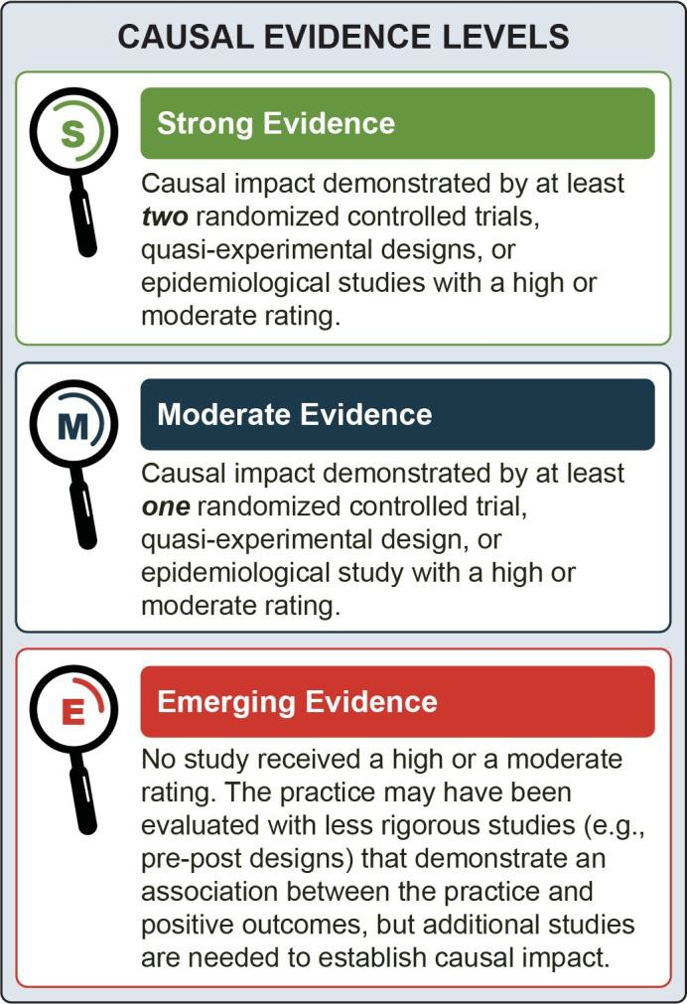

Identification of Programs Associated with Treatment of Suicidal Ideation, Self-Harm, and Suicide Attempts Among Youth

Dialectical Behavior Therapy (DBT)

Emotional dysregulation is the inability to flexibly respond to and manage emotions.


Overview
DBT is a manualized, cognitive-behavioral treatment that includes concurrent individual therapy, family therapy, multifamily skills training, and telephone coaching.
DBT therapists hold regular team consultation meetings to address treatment adherence, continue training, and manage caseloads and potential burnout. DBT was designed for treatment of adult patients with chronic suicidal ideation diagnosed with borderline personality disorder (BPD). Emotional dysregulation caused by BPD can result in self-harm and suicidal behaviors.¹⁻² The goal of DBT is to help individuals develop more effective behavioral, emotional, and interpersonal patterns.¹⁻² DBT emphasizes the development of four skills:
- Mindfulness
- Interpersonal effectiveness
- Emotion regulation
- Distress tolerance
Adolescents with BPD exhibit frequent suicidal ideation or behavior, and suicide attempts are common.³ DBT was adapted for adolescents due to the treatment’s effectiveness with suicidal behaviors in adults.⁴
The intervention also focuses on retaining clients in treatment, which research shows is a challenge for youth experiencing suicidal thoughts and behaviors.⁵⁻⁶
As adapted for adolescents, DBT focuses on treating youth with repeated self-harm and symptoms of BPD, many of whom also meet the Diagnostic and Statistical Manual of Mental Disorders (DSM–5) diagnostic criteria for depression and other mental disorders. It includes parents in treatment through multi-family group skills training and some family sessions. These adaptations tailor the adult version for the adolescent developmental stage and typically include youth ranging from 12 to 18 years old.

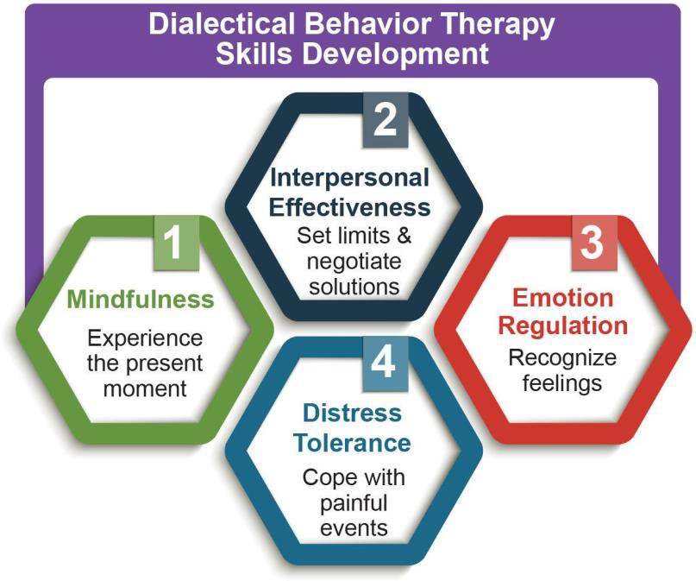

This review included eight studies conducted in outpatient settings with adolescents.^{3,5-13} While the overall treatment approach was similar across studies, the two randomized controlled trials (RCTs) used slightly different variants
of DBT, with one study using a sample of youth with more severe needs and a longer treatment duration.⁵ It is important to note that the outcomes below are from implementing the full treatment package, which can be challenging to sustain in a community setting.

Outcomes Associated with DBT
Studies included in this evidence review demonstrated that use of DBT for youth with suicidal thoughts and behaviors was associated with reductions in one or more of the following outcomes:
- Suicidal ideation
- Self-harm (non-suicidal)
- Self-harm (intent unknown)
- Suicide attempts
The studies included several additional outcomes, including improvement in BPD, reduced psychiatric hospitalizations, reduced depressive symptoms, and improved treatment completion rate.

Typical Settings
DBT has shown efficacy when delivered in an outpatient setting and has been implemented in community clinics serving primarily ethnic minority youth with low income. Some data also support particular benefits among non- white youth and Latino youth.¹⁴ However, DBT has
been used with promising results in a wide range of settings, including intensive outpatient programs, regular outpatient care, and psychiatric inpatient units.
Of the studies reviewed, two were conducted in Norway,^{6,8,10} two in Germany,^{3,12} one in Canada,⁹ and three in the United States.^{5,7,11}

Demographic Groups
DBT is intended for use across all sexual and gender identities, races, and ethnicities. All DBT studies included in this review comprised adolescents aged 12 to
- Participants were predominately female. The criteria

for participant inclusion varied across all reviewed studies. However, common criteria were:
  - Suicidal thoughts or behavior
  - Meeting at least two criteria of BPD or having a previous diagnosis of BPD
Exclusion criteria varied greatly across the studies reviewed. Some of the common exclusion criteria were different severities of mania and psychosis, as well as substance use and eating disorders.

Practitioner Types
DBT can be delivered by mental health practitioners, including licensed behavioral health professionals such as psychiatrists, psychologists, and therapists. At least one study included post-doctoral students, psychiatry
fellows, and graduate students as DBT practitioners, in addition to licensed therapists and clinical workers.¹¹

Intensity and Duration of Treatment
The two variants of DBT tested in RCTs varied in duration. One was 19 weeks and the other was 6
months.⁵⁻⁶ The frequency of DBT for adolescents includes one weekly individual session, weekly 2-hour multi- family groups, and some family sessions. Individual sessions last 1 hour. Telephone coaching for adolescents and parents is also available, 24 hours every day.
Finally, DBT training is offered free via SAMHSA’s Technology Transfer Centers. More information on training resources can be found in Chapter 3.

Attachment Based Family Therapy (ABFT)
ABFT’s Five Treatment Tasks18
- Relational Reframe Task
- Adolescent Alliance Task
- Parental Alliance Task
- Attachment Task
- Autonomy Promoting Task


Overview
ABFT is a manualized family therapy model specifically designed to treat depression and suicidal thoughts
and behaviors in adolescents.¹⁵ ABFT seeks toprotect adolescents against suicidal ideation and risk behaviors by improving family processes and repairing or building secure parent-child bonds.¹⁶⁻¹⁸
ABFT is designed to be structured while also being flexible enough to address the unique challenges each family brings to treatment.^{15,19} The ABFT treatment manual outlines five sequential tasks the therapist will lead the client and family through during the course of treatment. To accomplish each task, the practitioner employs a primarily process-oriented, emotion-focused approach, using strategies identified for each.¹⁵ Each task builds on the one preceding it, leading to the desired treatment outcome. Multiple sessions may be necessary depending on the needs of the adolescent and caregivers.¹⁹ Initial sessions focus on repairing or building attachment bonds, and later sessions focus on promoting adolescent autonomy.¹⁸
This review included three rigorous studies conducted in outpatient treatment facilities with adolescents scoring above a threshold on validated measures for suicidal ideation, depression, or both.^{15-16,20-21} Studies of ABFT have demonstrated an impact on severity of suicidal ideation but not suicidal behavior.

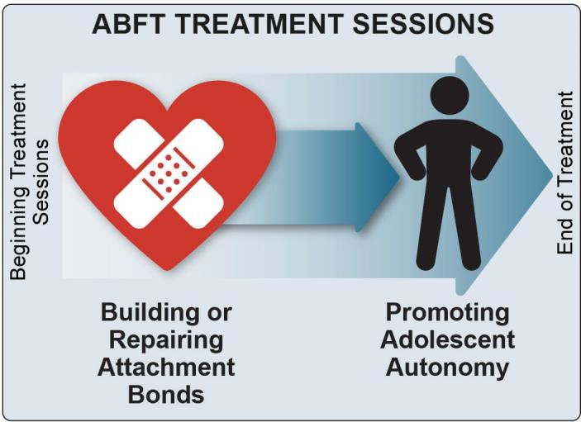

Typical Settings
ABFT can be administered as either an inpatient or outpatient treatment. Typical settings for conducting treatment include the family home, hospitals, outpatient clinics, community-based organizations, group or residential care facilities, and schools.²² All studies included in this review administered ABFT as outpatient treatment in a research clinic setting.^{15-16,20-21}

Demographic Groups
Outcomes Associated with ABFT
Some studies included in this evidence review demonstrated that use of ABFT for youth with suicidal thoughts and behaviors was associated with reductions in:
- Suicidal ideation
One of the studies included suicide attempts as an outcome. Although there were fewer suicide attempts in the group receiving ABFT than in the group receiving treatment as usual, the difference was not statistically significant.21 The studies
did not measure self-harm (non-suicidal or intent unknown) outcomes.
Studies also demonstrated improved outcomes related to treatment retention, reduced depressive symptoms, and improved attachment- related anxiety and avoidance.15-16,20-21
ABFT is designed to treat youth aged 12 to 25 and engages family members of all ages in treatment. The treatment has been useful for adolescents with diverse gender, sexual, racial, and cultural identities, in addition to adolescents with a history of sexual abuse.²³
The studies in this review include two primarily female, African American samples, as well as a sample comprised entirely of racial and ethnic minority adolescents with low income who identify as lesbian,
gay, or bisexual. All studies excluded youth with current psychosis or severe cognitive impairment. For purposes of research methodology (not clinical purposes), RCTs enforced additional exclusion criteria, including:
    - Imminent risk of harm to self or others that could not be safely treated on an outpatient basis
    - Participating parent who was non-English-
speaking

    - Treatment with psychotic medication within 3 weeks of the initial pretreatment screening15-16,20-21

Practitioner Types
ABFT practitioners are typically licensed and possess a minimum of a master’s degree in the mental health field. If a therapist is not licensed, he or she must be practicing under a supervisor’s license at their organization. ABFT has been used in teams with co-practitioners who have an undergraduate degree.
Practitioners participating in this review’s studies were doctoral or master’s level therapists trained and certified in ABFT.15-16,20-21

Intensity and Duration of Treatment
ABFT is designed to last approximately 12 to 16 weeks and span 10 to 20 sessions.¹⁹ In practice, therapists have adapted the model to fit the context and families with whom they work. The studies included in this review lasted from 12 to 16 weeks and averaged 8 to 12 sessions.^{15-16,20-21}

Programs that Show Promise - More Research Needed

Research on youth suicide treatment programs is relatively new. Prior to 2012, no programs had strong evidence to support their effectiveness in youth.²⁴ Although the body of research is growing, providers continue to face the challenge of limited evidence, particularly from RCTs, when selecting programs to treat suicidal thoughts and behaviors in youth.
There are many reasons for this research gap. Researchers may not be able to ethically assign youth to a no-treatment or treatment-as-usual group if the intervention being studied is potentially lifesaving.
Another reason is that with a relatively uncommon outcome, such as suicide attempts, an RCT may not be able to enroll enough youth to see a statistical improvement, even if the treatment works.²⁵ For these reasons, providers may want to consider programs that have been studied and show promise of effectiveness,
but for which multiple RCTs are currently unavailable.
The remainder of this chapter includes short descriptions of four programs that are either newly developed or have recently been adapted to address suicidal thoughts and behaviors: Multisystemic Therapy-Psychiatric, Safe Alternatives for Teens and Youth, Integrated Cognitive Behavioral Therapy, and Youth Nominated Support Team Intervention for Suicidal Adolescents-Version
- Each program has shown positive study outcomes. Technical experts agree that these programs include key elements important for treatment of suicidal thoughts and behaviors. However, they have various limitations in their current evidence base, such as:
  - Program has not yet been studied in multiple RCTs
  - Findings of subsequent RCTs are not yet
published
  - Multiple RCTs have been conducted for other outcomes, but not yet for suicidal thoughts and behavior
This resource guide does not provide evidence ratings for these promising interventions. The programs are described here to offer information to researchers and
those treating youth. This information is important at a time when additional research is needed, youth suicide rates are rising, and relatively few programs are available for youth that have demonstrated well- established effectiveness for treating suicidal thoughts and behaviors.
The first of four promising programs is Multisystemic Therapy-Psychiatric (MST-Psych). MST is an intensive manualized treatment developed for youth aged 12 to 17 with serious antisocial behavior, most of whom have had involvement with the criminal justice system.²⁶ Youth diagnosed with conduct disorder, the childhood disorder most associated with antisocial behaviors, have a greater rate of suicide attempts compared to youth without conduct disorder.²⁷ MST provides a useful approach in that it draws from the social-ecological theory of human development, which emphasizes that treatment must address the strengths and challenges of the systems with which youth interact (e.g., family, peer, school, larger society).²⁸ The social-ecological theory recognizes that all of these systems affect youth, and that youth, in turn, affect many different systems.
MST-Psych is an adaptation of MST specifically designed for adolescents with high-risk symptoms, such as suicidal, self-injurious, and aggressive behavior.²⁹ Treatment focuses on improving caregiver and family functioning and working with the family to address risk factors present in the systems with which the adolescentinteracts.²⁹
MST-Psych has been used in both home- and community- based settings.³⁰ Most families receive services for 3 to 6 months, although there is no defined length of treatment.²⁸
Some studies have demonstrated MST-Psych’s effectiveness in reducing serious behaviors, such as violence, substance use, and criminal activity. One of these studies examined the use of MST-Psych with youth aged 10 to 17 presenting for emergency hospitalization for suicidal intent/planning, attempted suicide, homicidal ideation or behavior, psychosis, or other threat of harm to self or others. The majority of participating youth were African American andmale.²⁹

The study demonstrated that youth who received home- based MST-Psych experienced a greater reduction in suicide attempts at 1-year follow-up compared to youth assigned to inpatient hospitalization. However, youth in the MST-Psych group had a history of more suicide
attempts on average than did youth in the hospitalization group. This difference may have affected the study results.²⁸
Additional studies that are focused on suicidal ideation, self-harm, and suicide attempt outcomes could strengthen the body of evidence for use of MST-Psych in treating suicidal thoughts and behaviors.
A second promising program is Safe Alternatives for Teens and Youth (SAFETY). SAFETY is a 12-week family-oriented treatment designed to build skills, increase safety, and reduce risk of suicide attempts.
This cognitive-behavioral program is informed by DBT and grounded in social-ecological theory. It enhances protective factors and reduces risk factors within individual youth, family, and other social systems. The program is designed for adolescents aged 11 to 18 and their families.
SAFETY is a community-based treatment conducted in outpatient settings and/or the client’s home. It provides treatment after a suicide attempt or recent, repeated clinically significant self-harm, and is often used for youth with recent emergency, hospital, or crisis visits for suicide attempts and/or self-harm.
Elements of SAFETY include:
- Youth work with one therapist while parents simultaneously work with a different therapist
- Youth and family come together to practice skills identified as important to prevent repeat suicide attempts³¹⁻³²
When the family is not available or involvement of the young person’s parents is not feasible or otherwise inadvisable, the therapist may include other protective adults in treatment.
The 12-week SAFETY program builds upon an emergency intervention called SAFETY-Acute (SAFETY-A), initially described in the literature as Family Intervention for Suicide Prevention (FISP).³³⁻ ³⁴ When delivered with community treatment as
usual, SAFETY-A/FISP has demonstrated benefits for improving continuity of care after an emergency
department (ED) visit for suicidal ideation and behavior, with some data supporting benefits on suicidal ideation at discharge from the ED.³⁴⁻³⁵
SAFETY-A is included as the first session in the full SAFETY program and emphasizes a developmentally nuanced, trauma-informed, family-centered, and strengths-based approach to safety planning. Upon conclusion of the SAFETY program, the therapist links youth and families to follow-up services and resources to encourage ongoing care.
Studies have demonstrated that use of SAFETY for youth with suicidal thoughts and behaviors was
associated with reductions in suicidal ideation, self- harm (non-suicidal), and suicide attempts. In the studies reviewed, participants were primarily female and represented diverse subgroups across racial, ethnic, socioeconomic, and sexual orientation categories.
One of the studies demonstrated significant reductions in depression and hopelessness for youth and significant reductions in depression for parents involved in the intervention.³⁰ An additional RCT on this program showed measurable reductions in suicide outcomes. The inclusion of more gender diverse youth would improve SAFETY’s evidence base.
A third program that shows promise in reducing suicidal thoughts and behaviors among youth is Integrated Cognitive Behavioral Therapy (I-CBT). I-CBT uses cognitive, behavioral and affect regulation training to address suicidal behaviors and co-occurring substance use disorders among adolescents, as well as common comorbid conditions (e.g., depression, conduct problems) that may interfere with treatment progress.
The intervention extends 12 months and consists of three treatment phases involving individual, family, and parent training sessions.³⁶
A key component of I-CBT for suicide treatment is that it targets common thought processes and behaviors that underlie substance use disorders, suicidal thoughts/ behaviors, and comorbid mental health conditions.
I-CBT provides a framework for teaching youth the skills needed to develop self-efficacy to manage their emotions, challenge negative thoughts, solve problems,

and communicate effectively. Parents play a significant role in treatment. They learn skills to aid in their adolescent’s recovery and promote supportive family relationships, such as problem-solving, communication, emotional regulation, and monitoring.
- CBT has been further adapted by its creators to a program called Family-focused Cognitive Behavioral Therapy (F-CBT) based on clinical impressions during the I-CBT study and emerging research.³⁷ Additional session focus areas were added to accommodate a more heterogeneous sample of youth experiencing suicidal thoughts or behaviors. Parental involvement and support were expanded by adding parental “self-care” sessions and an emotional coaching session to improve parent- child interactions.³⁷
Preliminary research found that I-CBT for youth with suicidal thoughts and behaviors was associated with reductions in suicide attempts. The program also demonstrated reductions in the frequency of marijuana use and heavy drinking days, as well as in the number of inpatient hospitalizations, ED visits, and arrests.³⁵
To improve the field’s understanding of I-CBT’s effectiveness, additional studies should be conducted to:
  - Observe the treatment in a variety of settings
  - Include more racially, ethnically, and gender diverse youth
  - Establish stronger findings across multiple
suicide outcomes (i.e., suicidal ideation, self- harm, and suicide attempts)
A fourth promising program is Youth Nominated Support Team Intervention for Suicidal Adolescents- Version II (YST-II). YST-II is a psychoeducational social support program designed for adolescents hospitalized in a psychiatric unit who have recently reported a suicide attempt or serious suicidal ideation.
As a key component to suicide prevention, the intervention supplements routine treatment by strengthening existing adolescents’ support networks through increasing support from caring adults.
Adolescents nominate several adults (typically three to four per adolescent from family, school, and/



or community settings) to serve as their support persons after hospitalization.³⁸ These adults attend psychoeducational sessions to learn about:
  - The adolescent’s psychiatric disorder(s) and psychosocial difficulties
  - The adolescent’s treatment plan and rationale for recommended treatments
  - Risk factors for suicidal behavior and warning
signs of possible acute risk
  - Strategies for communicating with adolescents
  - Availability of emergency services (e.g., crisis lines, EDs)
The adults receive weekly, supportive telephone calls from YST-II staff for 3 months. The adults are
encouraged to have weekly contact with the adolescents for at least 3 months following hospital discharge.
In their regular contacts with adolescents, the youth- nominated caring adults:
  - Support the young person’s involvement in healthy activities
  - Inquire about and listen to the adolescent’s
concerns to engage in collaborative problem- solving
  - Support treatment adherence and express
hopefulness about the possibility of positive change³⁸
Preliminary research demonstrated YST-II was associated with reductions in suicidal ideation. Most participants were White, and three quarters were female. Approximately 20 percent had a co-occurring alcohol or substance use disorder.
YST-II resulted in more rapid decreases in suicidal ideation for youth with multiple suicide attempts during the initial 6 weeks after hospitalization. For those without multiple attempts, it was also associated with greater declines in functional impairment at 3 and 12 months.³⁷ Youth who received YST-II attended more outpatient therapy and medication follow-up sessions and were more likely to participate in outpatient drug or alcohol treatment in the 12 months following their initial hospitalization.³⁸⁻³⁹
A secondary analysis conducted more than a decade later found YST-II was associated with a reduction in mortality across all causes of death and a reduction in self-injury mortality due to either suicide or drug-related deaths with unknown intent.³⁹ Additional studies with stronger findings across multiple suicide outcomes (i.e., suicidal ideation, self-harm, and suicide attempts) and the inclusion of more racially, ethnically, and gender diverse youth would strengthen the field’sunderstanding of YST-II’s effectiveness.
The four programs described in this section have shown some positive outcomes in reducing suicidal thoughts and behaviors. In addition, each program highlights
key elements to consider for the treatment system in addressing suicide. However, more research is needed to conclude that the programs are effective treatments for suicidal ideation, self-harm, and suicide attempts among youth.



Reference List

¹ Linehan, M. (2015). DBT skills training manual
(2nd ed.). The Guilford Press.
² Linehan, M. (2015). DBT skills training handouts and worksheets (2nd ed.). The Guilford Press.
³ Fleischhaker, C., Böhme, R., Sixt, B., Brück, C., Schneider, C., & Schulz, E. (2011). Dialectical behavioral therapy for adolescents (DBT-A): A clinical trial for patients with suicidal and self- injurious behavior and borderline symptoms with a one-year follow-up. Child and Adolescent Psychiatry and Mental Health, 5(3). https://doi. org/10.1186/1753-2000-5-3
⁴ Dimeff, L., & Linehan, M. (2001). Dialectical behavior therapy in a nutshell. The California Psychologist, 34, 10-13.
⁵ McCauley, E., Berk, M. S., Asarnow, J. R., Adrian, M., Cohen, J., Korslund, K., Avina, C., Hughes, J., Harned, M., Gallop, R., & Linehan, M. M. (2018). Efficacy of dialectical behavior therapy for adolescents at high risk for suicide: A randomized clinical trial. JAMA Psychiatry, 75(8), 777-785. https://doi.org/10.1001/jamapsychiatry.2018.1109
⁶ Mehlum, L., Tørmoen, A. J., Ramberg, M., Haga, E., Diep, L. M., Laberg, S., Larsson, B. S., Stanley,
B. H., Miller, A. L., Sund, A. M., & Grøholt, B. (2014). Dialectical behavior therapy for adolescents with repeated suicidal and self-harming behavior: A randomized trial. Journal of the American Academy of Child and Adolescent Psychiatry, 53(10), 1082- 1091. https://doi.org/10.1016/j.jaac.2014.07.003
⁷ Rathus, J. H., & Miller, A. L. (2002). Dialectical behavior therapy adapted for suicidal adolescents. Suicide & Life-Threatening Behavior, 32(2), 146-
157. https://onlinelibrary.wiley.com/doi/abs/10.1521/ suli.32.2.146.24399
⁸ Tørmoen, A. J., Grøholt, B., Haga, E.,Brager-Larsen, A., Miller, A., Walby, F., Stanley, B., & Mehlum, L. (2014). Feasibility of dialectical behavior therapy with suicidal and self-harming adolescents with
multi-problems: Training, adherence, and retention. Archives Of Suicide Research, 18(4), 432-444. https://doi.org/10.1080/13811118.2013.826156
⁹ Courtney, D. B., & Flament, M. F. (2015).Adapted dialectical behavior therapy for adolescents with self-injurious thoughts and behaviors. The Journal of Nervous and Mental Disease, 203(7), 537-544. https://doi.org/10.1097/NMD.0000000000000324
¹⁰ Mehlum, L., Ramberg, M., Tørmoen, A. J., Haga, E., Diep, L. M., Stanley, B. H., Miller, A. L.,Sund,
A. M., & Grøholt, B. (2016). Dialectical behavior therapy compared with enhanced usual care for adolescents with repeated suicidal and self-harming behavior: Outcomes over a one-year follow-up. Journal of the American Academy of Child and Adolescent Psychiatry, 55(4), 295-300. https://doi. org/10.1016/j.jaac.2016.01.005
¹¹ Berk, M. S., Starace, N. K., Black, V. P., &Avina,
C. (2020). Implementation of dialectical behavior therapy with suicidal and self-harming adolescents in a community clinic. Archives Of Suicide Research, 24(1), 64-81. https://doi.org/10.1080/138 11118.2018.1509750
¹² Buerger, A., Fischer-Waldschmidt, G., Hammerle, F., Auer, K. v., Parzer, P., & Kaess, M. (2019). Differential change of borderline personality disorder traits during dialectical behavior therapy for adolescents. Journal of Personality Disorders, 33(1), 119-134. https://doi.org/10.1521/pedi_2018_32_334
¹³ Mehlum, L., Ramleth, R.-K., Tørmoen, A. J., Haga, E., Diep, L. M., Stanley, B. H., Miller, A.L., Larsson, B., Sund, A. M., & Grøholt, B. (2019). Long term effectiveness of dialectical behavior therapy versus enhanced usual care for adolescents with self-harming and suicidal behavior. Journal of Child Psychology and Psychiatry and Allied Disciplines, 60(10), 1112-1122. https://www.doi. org/10.1111/jcpp.13077
¹⁴ Adrian, M., McCauley, E., Berk, M. S., Asarnow,
J. R., Korslund, K., Avina, C., Gallop, R., & Linehan, M. M. (2019). Predictors and moderators of recurring self-harm in adolescents participating in a comparative treatment trial of psychological interventions. Journal of Child Psychology and Psychiatry and Allied Disciplines, 60(10), 1123- 1132. https://www.doi.org/10.1111/jcpp.13099
¹⁵ Diamond, G. S., Wintersteen, M. B., Brown, G. K., Diamond, G. M., Gallop, R., Shelef, K., & Levy,
S. (2010). Attachment-based family therapy for adolescents with suicidal ideation: A randomized controlled trial. Journal of the American Academy of Child and Adolescent Psychiatry, 49(2), 122-131.
https://doi.org/10.1097/00004583-201002000-00006

¹⁶ Diamond, G. M., Diamond, G. S., Levy, S., Closs, C., Ladipo, T., & Siqueland, L. (2012).
Attachment-based family therapy for suicidal lesbian, gay, and bisexual adolescents: A treatment development study and open trial with preliminary findings. Psychotherapy, 49(1), 62-71. https://doi. org/10.1037/a0026247
¹⁷ Drexel University Center for Family Intervention Science. (n.d.). Attachment-based family therapy. https://drexel.edu/familyintervention/attachment- based-family-therapy/overview/
¹⁸ Diamond, G., Diamond, G., & Levy, S. (2014). Attachment-based family therapy for depressed adolescents. https://psycnet.apa.org/ doi/10.1037/14296-000
¹⁹ Krauthamer Ewing, E. S., Levy, S. A., Boamah- Wiafe, L., Kobak, R., & Diamond, G. (2016). Attachment-based family therapy with a 13-year-old girl presenting with high risk for suicide. Journal of Marital and Family Therapy, 42(1), 91-105. https:// doi.org/10.1111/jmft.12102
²⁰ Diamond, G. M., Diamond, G. S., Levy, S., Closs, C., Ladipo, T., & Siqueland, L. (2013). “Attachment- based family therapy for suicidal lesbian, gay, and bisexual adolescents: A treatment development study and open trial with preliminary findings”: Correction to Diamond et al. (2011). Psychotherapy, 50(4), 596- 596. https://doi.org/10.1037/a0034920
²¹ Diamond, G. S., Kobak, R. R., Krauthamer Ewing, S., Levy, S. A., Herres, J. L., Russon, J. M., Gallop, R. J. (2019). A Randomized Controlled Trial: Attachment-Based Family andNondirective
Supportive Treatments for Youth Who Are Suicidal. Journal of the American Academy of Child & Adolescent Psychiatry, 58(7), 721-731. https://doi. org/10.1016/j.jaac.2018.10.006
²² The California Evidence-Based Clearninghouse for Child Welfare. (2020). Attachment-based family therapy. https://www.cebc4cw.org/program/ attachment-based-family-therapy/
²³ Diamond, G., Creed, T., Gillham, J., Gallop, R., & Hamilton, J. L. (2012). Sexual trauma history does not moderate treatment outcome in attachment-based family therapy (ABFT) for adolescents with suicide ideation. Journal of Family Psychology, 26(4), 595- 605. https://doi.org/10.1037/a0028414
²⁴ Asarnow, J., & Mehlum, L. (2019). Practitioner review: Treatment for suicidal and self-harming adolescents – Advances in suicide prevention care. Journal of Child Psychology and Psychiatry, 60, 1046-1054. https://doi.org/10.1111/jcpp.13130
²⁵ Robinson, J., Bailey, E., Witt, K., Nina, S., Milner, A., Currier, D., Condron, P., & Hetrick, S. (2018). What works in youth suicide prevention? A systematic review and meta-analysis. The Lancet, 4, 52-91. https://doi.org/10.1016/j.eclinm.2018.10.004
²⁶ Youth.gov. (n.d.). Multisystemic therapy (MST). https://youth.gov/content/multisystemic-therapy-mst
²⁷ McCloskey, M. S., & Ammerman, B. A. (2018). Suicidal behavior and aggression-related disorders. Current Opinion in Psychology, 22, 54-58. https:// doi.org/10.1016/j.copsyc.2017.08.010
²⁸ Huey, S. J., Jr., Henggeler, S. W., Rowland, M. D., Halliday-Boykins, C. A., Cunningham, P. B., Pickrel,
S. G., & Edwards, J. (2004). Multisystemic therapy effects on attempted suicide by youths presenting psychiatric emergencies. Journal of the American Academy of Child and Adolescent Psychiatry, 43(2), 183-190. https://doi.org/10.1097/00004583- 200402000-00014
²⁹ Rowland, M. D. (2019). A psychiatric adaptation of multisystemic therapy for suicidal youth. In M. Berk (Ed.), Evidence-based treatment approaches for suicidal adolescents: Translating science into practice (pp. 191-228). American Psychiatric Association Publishing.
³⁰ Littell, J. H. (2005). Lessons from a systematic review of effects of multisystemic therapy. Children and Youth Services Review, 27(4), 445-463. https:// doi.org/10.1016/j.childyouth.2004.11.009
³¹ Asarnow, J. R., Berk, M., Hughes, J. L., & Anderson, N. L. (2015). The SAFETY Program: A treatment-development trial of a cognitive- behavioral family treatment for adolescent suicide
attempters. Journal of Clinical Child and Adolescent Psychology, 44(1), 194-203. https://doi.org/10.1080/
15374416.2014.940624
³² Asarnow, J. R., Hughes, J. L., Babeva, K. N., & Sugar, C. A. (2017). Cognitive-behavioral
family treatment for suicide attempt prevention: A randomized controlled trial. Journal of the American Academy of Child and Adolescent Psychiatry, 56(6), 506-514. https://doi.org/10.1016/j.jaac.2017.03.015
³³ Asarnow, J. R., Berk, M. S., & Baraff, L. J. (2009). Family Intervention for Suicide Prevention: A specialized emergency department intervention
for suicidal youths. Professional Psychology: Research and Practice, 40(2), 118-125. https://doi. org/10.1037/a0012599

³⁴ Asarnow, J. R., Baraff, L. J., Berk, M., Grob, C. S., Devich-Navarro, M., Suddath, R.,Piacentini,
J. C., Rotheram-Borus, M. J., Cohen, D., & Tang,
L. (2011). An emergency departmentintervention for linking pediatric suicidal patients to follow- up mental health treatment. Psychiatric Services,
62(11), 1303-1309. https://doi.org/10.1176/ps.62.11. pss6211_1303
³⁵ Rotheram-Borus, M. J., Piacentini, J., Van Rossem, R., Graae, F., Cantwell, C., Castro-Blanco, D., Miller, S., & Feldman, J. (1996). Enhancing treatment adherence with a specialized emergency room program for adolescent suicide attempters. Journal of the American Academy of Child and Adolescent Psychiatry, 35(5), 654-663. https://doi. org/10.1097/00004583-199605000-00021
³⁶ Esposito-Smythers, C., Spirito, A., Kahler, C. W., Hunt, J., & Monti, P. (2011). Treatment of co-occurring substance abuse and suicidality
among adolescents: a randomized trial. Journal of Consulting and Clinical Psychology, 79(6), 728-739. https://doi.org/10.1037/a0026074
³⁷ Esposito-Smythers, C., Wolff, J. C., Liu, R. T., Hunt, J. I., Adams, L., Kim, K., Frazier, E. A., Yen, S., Dickstein, D. P., & Spirito, A. (2019). Family-
focused cognitive behavioral treatment for depressed adolescents in suicidal crisis with co-occurring
risk factors: A randomized trial. Journal of Child Psychology and Psychiatry and Allied Disciplines, 60(10), 1133-1141. https://doi.org/10.1111/ jcpp.13095
³⁸ King, C. A., Klaus, N., Kramer, A., Venkataraman, S., Quinlan, P., & Gillespie, B. (2009). The youth- nominated support team-version II for suicidal adolescents: A randomized controlled intervention trial. Journal of Consulting and Clinical Psychology, 77(5), 880-893. https://doi.org/10.1037/a0016552
³⁹ King, C. A., Arango, A., Kramer, A., Busby, D., Czyz, E., Foster, C. E., & Gillespie, B. W. (2019).
Association of the youth-nominated support team intervention for suicidal adolescents with 11- to 14-year mortality outcomes: Secondary analysis of a randomized clinical trial. JAMA
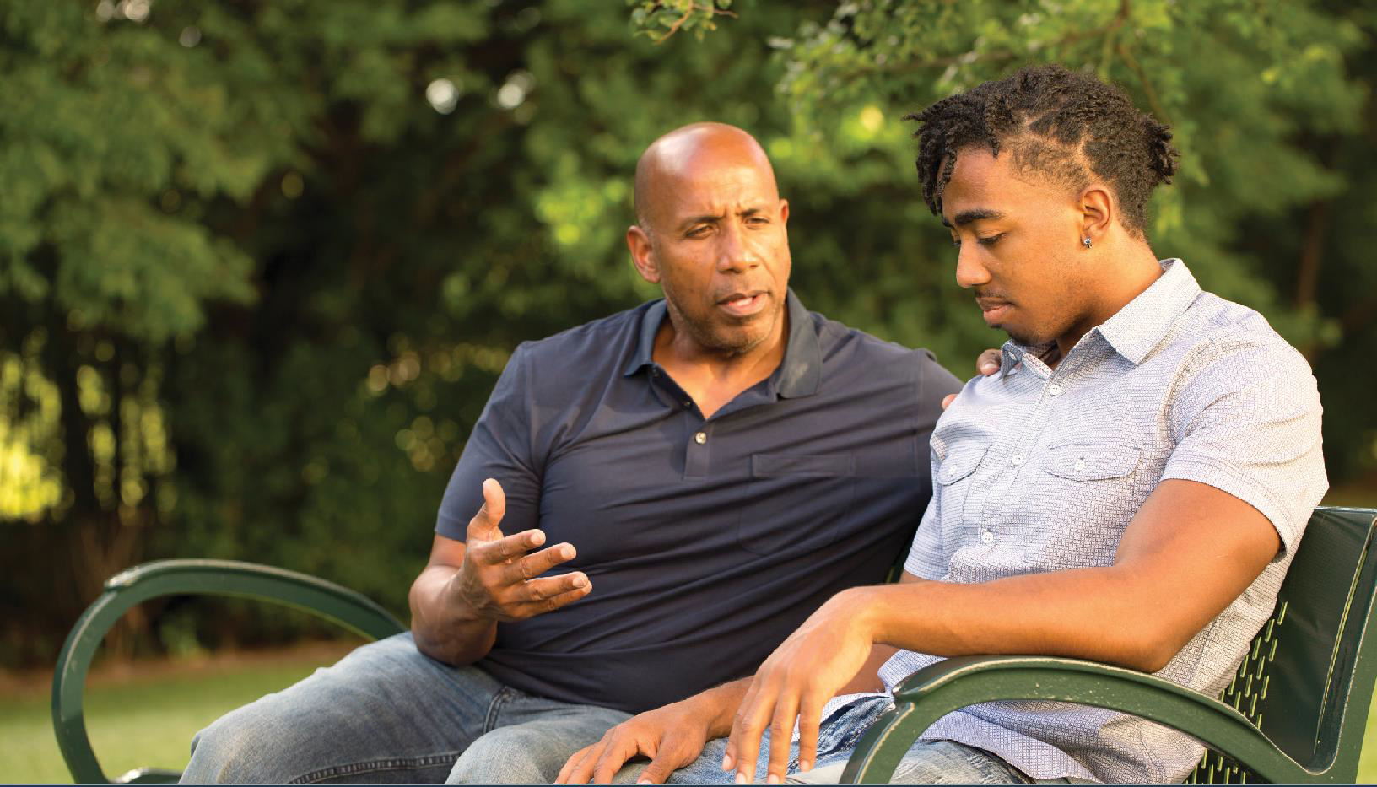
Psychiatry, 76(5), 492-498. https://doi.org/10.1001/ jamapsychiatry.2018.4358

This chapter provides information for clinicians, program administrators, and other stakeholders interested in implementing evidence-based programs to treat suicidal ideation, self-harm, and suicide attempts among youth. The chapter:
3CHAPTER
Guidance for Selecting and Implementing Evidence-based Programs
  - Reviews the steps to implementing a new program
  - Identifies common elements of effective
programs to treat suicidal thoughts and behaviors
  - Includes key program selection and
implementation considerations and strategies
  - Provides implementation resources for the treatment programs described in Chapter 2

Implementation of Evidence-Based Programs
A number of general frameworks and guidelines provide insight into how to implement new programs and practices.¹⁻² A comprehensive youth suicide treatment program planning and implementation process typically includes the following steps:
- Plan: Identify populations of focus, current treatment gaps, and internal capacity to implement a new program through an organizational readiness and needs assessment process. This process should include a review of qualitative and quantitative data and budget requirements.
- Engage Youth with Lived Experience: Within the limits of the program, practitioners should involve youth suicide attempt survivors and young people with a range of relevant lived experience, including graduates of treatment programs, as an integral resource and voice
to inform the implementation, adaptation, and evaluation of programs. Provide leadership roles for youth to serve on agency boards of directors and community councils, as appropriate.
- Build Buy-in and Capacity: Communicate goals and expectations, facilitate understanding about program theory and build support among staff. Select and train staff and supervisors to support implementation of the new program. Offer trainings to new staff and booster training or coaching sessions for existing staff to enhance skills.
- Implement: Pilot test the program and refine, if needed, before scaling up to full implementation.
- Evaluate: Monitor practice change and quality of program delivery through observation, staff input, and data. Evaluate the implementation process and assess whether the program is achieving the desired outcomes (see details in Chapter 5).

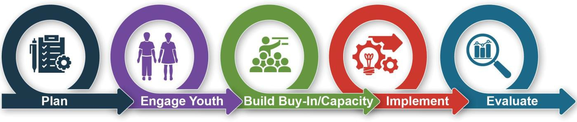

Common Elements of Effective Treatment Programs
The evidence base for treatment of suicidal ideation, self-harm, and suicide attempts continues to emerge. There is no one-size-fits-all treatment approach. Care should be taken to select the program that best fits the characteristics and needs of the youth who will be served.
Regardless of the specific program selected, this guide’s review of relevant research and discussions with content experts identified a set of common elements that should be strongly considered prior to treatment and within treatment programs:
  - Comprehensive assessment to inform treatment
  - Safety planning
  - Family involvement in separate or joint sessions
  - Coping skills training to match needs identified in the assessment
  - Promotion of continuity of care
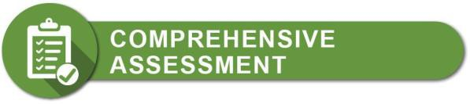
Prior to initiating treatment or during the first sessions, a comprehensive clinical assessment or history of a client’s thoughts, behaviors, mood, previous suicide attempts, trauma, health history, and home life should be completed using a structured or semi-structured approach (e.g., using a combination of assessment tools and/or clinical interviews).This initial assessment can assist providers in identifying suicide risk, determining appropriate next steps, and tailoring specific treatment modules to meet specific needs. Clinicians should also
regularly administer one or a sub-set of brief tools based on the patient’s presenting problems to track the youth’s progress over time and adjust the treatment plan accordingly, consistent with measurement-based care.³

Measurement-based care is the systematic administration of symptom rating scales and use of the results to drive clinical decision making at the level of the individual patient.3

An example of a free assessment tool for identifying youth at risk for suicide during an initial assessment is the Ask Suicide-Screening Questions (ASQ) Toolkit.⁴ HealthMeasures includes PROMIS® and the NIH Toolbox®, two free comprehensive sets of neuro- behavioral measurements that assess a broad range of symptoms and risk and resilience factors that could be used at intake and to monitor patients over time.⁵

The Collaborative Assessment and Management of Suicidality (CAMS) is a therapeutic framework in which the client and provider work together to assess the client’s suicidal risk and use that information to plan and manage suicide-specific treatment. CAMS is a widely used intervention but it’s efficacy for youth has not been tested. CAMS incorporates the Suicide Status Form (SSF) to assess the client and guide the development of a treatment plan. The SSF has been validated for use with youth aged 12 to 17.6

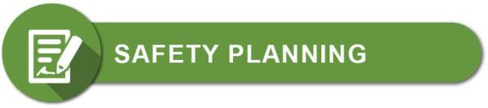
Safety planning is an essential intervention andcomponent of an evidence-based treatment approach. Research has shown that individuals who receive safety planning are less likely to experience suicidal behavior, less likely
to be hospitalized in the following year, and more than twice as likely to receive mental health services.⁷ A safety plan is a prioritized list of coping strategies and sources of support that youth can use before or during a suicidal crisis and is often completed before starting treatment and/or during the first session. Safety plans
are based on clear communication and a collaborative relationship between the client and provider, and are differentiated from previously used safety contracts
– which the evidence has found are not effective – by including clear direction and support for addressing a suicidal crisis. Clinicians should collaborate with youth and their parents (if it is safe and appropriate to involve the family) at the beginning of a treatment program to develop a safety plan that is brief, in the youth’s own words, and easy to read.⁸⁻⁹
Parents or other adult family members should also receive instruction on how to monitor for suicidal thoughts and behavior, recognize warning signs, and support their child in using the safety plan. In addition, parents should be taught when, where, and how to access emergency care for their child when needed.
For individuals at higher risk, safety plans should be revisited over the course of treatment.
Clinicians should also counsel the youth’s family on ways to reduce access to lethal means, such as removing firearms, medications, or sharp objects from the home. Counseling on Access to Lethal Means (CALM) is one example of a training resource for clinicians in this area.¹⁰
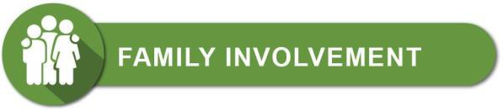
Involving parents, caregivers, or other supportive adults in the youth’s treatment program can help strengthen
a youth’s support system, increasing the youth’s help seeking behaviors and creating positive interpersonal relationships. The literature shows that different aspects
of family life and relationships can serve as either risk or protective factors for suicide and self-harm. Separate parent or integrated family sessions may focus on emotional regulation, improving communication, parent monitoring, and resolving family conflicts that have strained the parent-child bond.
When involving family, some programs use two therapists throughout the treatment process, one focused on the adolescent and one focused on the parents or caregivers.
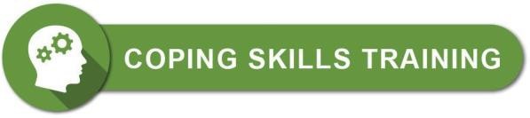
Skills training during treatment involves youth learning, practicing, and applying a variety of coping skills
that help youth better navigate everyday challenges and stressors. Skills training sessions may focus on emotional regulation, distress tolerance, cognitive restructuring, communication skills, help seeking, problem-solving, and/or conflict resolution.¹¹
This training should be calibrated with what put that youth at risk for suicide. For example, if an adolescent male client tends to experience suicidal thoughts after interpersonal conflicts with his friends, parents, and significant other, a clinician might prioritize different coping skills than for an adolescent female who suffers from perfectionism, anxiety, depression, and feelings of failure.

After acute treatment, it is important to consider additional treatment and service (e.g., mental health, health, school, housing, transportation) needs. Treatment that employs a collaborative approach that links the adolescent, as well as their family, to primary health care, behavioral health care, or community and school services and supports, can help engage and motivate the adolescent. This can increase retention in therapy and decrease suicidal thoughts and behavior.¹¹
Addressing barriers to care can also be helpful. Research shows that individuals experiencing suicidal thoughts and behaviors are less likely to initiate treatment, to attend only a few sessions, or to drop out of treatment

early.¹² Continuity of care strategies can improve connectedness, motivation, and treatment adherence, which help prevent future episodes of suicidal behaviors, and, in turn, relapse. Relapse prevention strategies also include enhancing youths’ self-esteem, autonomy, and resilience to distress, as well as avoiding alcohol and other drugs.¹³⁻¹⁴
Standard care for youth should include brief, non- demanding, repeated caring contacts expressing care, interest, and support following discharge. A case manager who provides assistance and follow-up support, especially during times of transition, can also assist with other psychosocial needs (e.g., paperwork related to housing or education) that impact suicidal thoughts and behavior but are not typically the focus of mental health interventions. Case managers should work with schools and campus counseling offices to engage clinical support in learning environments.

Considerations When Selecting and
Implementing Programs to Treat Suicidal Ideation, Self-Harm, and Suicide Attempts
When selecting and implementing optimal interventions to address suicidal thoughts and behaviors, there are several potential factors to consider, including:
- Treatment fidelity
- Adaptation of programs
- Treatment adherence and retention in care
- Program sustainability
These factors are described in detail below, along with recommended strategies to achieve optimal implementation.

Treatment Fidelity
Consideration: Fidelity is the extent to which a practitioner adheres to the core components of the program and is crucial to reaching desired outcomes.¹⁵ For youth experiencing suicidal thoughts and behaviors, this consideration is particularly important given that lack of improvement could result in an attempt or death by suicide.

Strategies:
- Monitor fidelity over time – For even the most experienced clinicians, suicide can be one of the most uncomfortable and challenging presenting problems to address with clients. Without ongoing efforts to maintain it, initially high treatment fidelity can diminish, even after only a few weeks following initial implementation of a program.¹⁵
Many programs in this guide have fidelity measures that can be implemented either as a self-assessment tool, or, if funding is available, by external expert evaluators. Practitioners should also frequently refresh their knowledge of the program by attending trainings, webinars, and other continuing education opportunities.
- Ensure the organizational environment supports fidelity - Organizations can support treatment fidelity by examining their existing systems and environment to determine whether they enable staff to carry out the program
as intended. The organization must have the infrastructure needed to support correct use of evidence-based treatment, reduce clinician burden, and prevent burnout.
Considerations may include current program offerings, the level of staff education, client characteristics, client intake processes, funding sources, the ability of clinicians to see clients on a regular basis (e.g., once a week or more often depending on the treatment selected), and time for clinicians to further study the treatment modules and prepare for each session. It is important for the organization and leaders to acknowledge how challenging it is to work with suicidal clients and to be transparent about the fidelity monitoring process.
- Develop in-house expertise - It is often advantageous for an organization to select staff to undergo supervision, trainings, and certification. In-house training and clinician supervision groups make professional development more easily accessible, help
prevent burnout, and ensure continued treatment fidelity over time. They can also help ensure
a built-in support system and more attention to self-care for clinicians working with youth experiencing suicidal thoughts or behaviors.

Adaptation of Programs
Consideration: While maintaining program fidelity is critical to achieving desired outcomes, certain elements of a program may not be appropriate or feasible to implement in specific contexts. Successful program implementation often requires adapting a program so
it is better suited for a particular population, program setting, or organization.
Strategies:
- Develop a plan for adaptations - Practitioners and program administrators should plan adaptations in advance to ensure core components of the program or practice are maintained and fidelity is not compromised.
When possible, they should consult with the treatment developers for guidance on
adaptations. They should also seek input from program stakeholders, including participants, and monitor program data to ensure the program is still achieving desired outcomes. Depending on the degree of adaptation of the originally validated intervention, the new version may or may not be as effective – which underscores the need for continued evaluation.

ADAPT-ITT, consisting of eight sequential phases, is a systematic framework for adapting evidence-based interventions.¹⁶ While it was initially designed for HIV-related interventions, the general process is applicable to many other types of programs.
- Adapt the program to better serve the population of focus - The most commonly cited reasons organizations adapt a program are for ensuring cultural competency and addressing a new population of focus.¹⁷
Cultural adaptions - Program implementers should consider how to tailor treatments to be compatible with the clients’ cultural patterns, meanings, and values.¹⁸ To make a program more culturally appropriate, it is important
to consider the preferred language, values, attitudes, beliefs, practices, and experiences of the cultural groups served.
For example, interventions for Native American youth experiencing suicidal thoughts or behaviors may need to address cultural beliefs and incorporate Native-specific language for the concept of suicide, as well as the importance of and ways to promote wellness.
Adaptations for LGBTQ youth - LGBTQ youth are youth who identify as lesbian, gay, bisexual, transgender, queer, or who are currently questioning their sexual orientation or gender identity. Programs may need to be adapted to better address the additional challenges that LGBTQ youth face.¹⁹

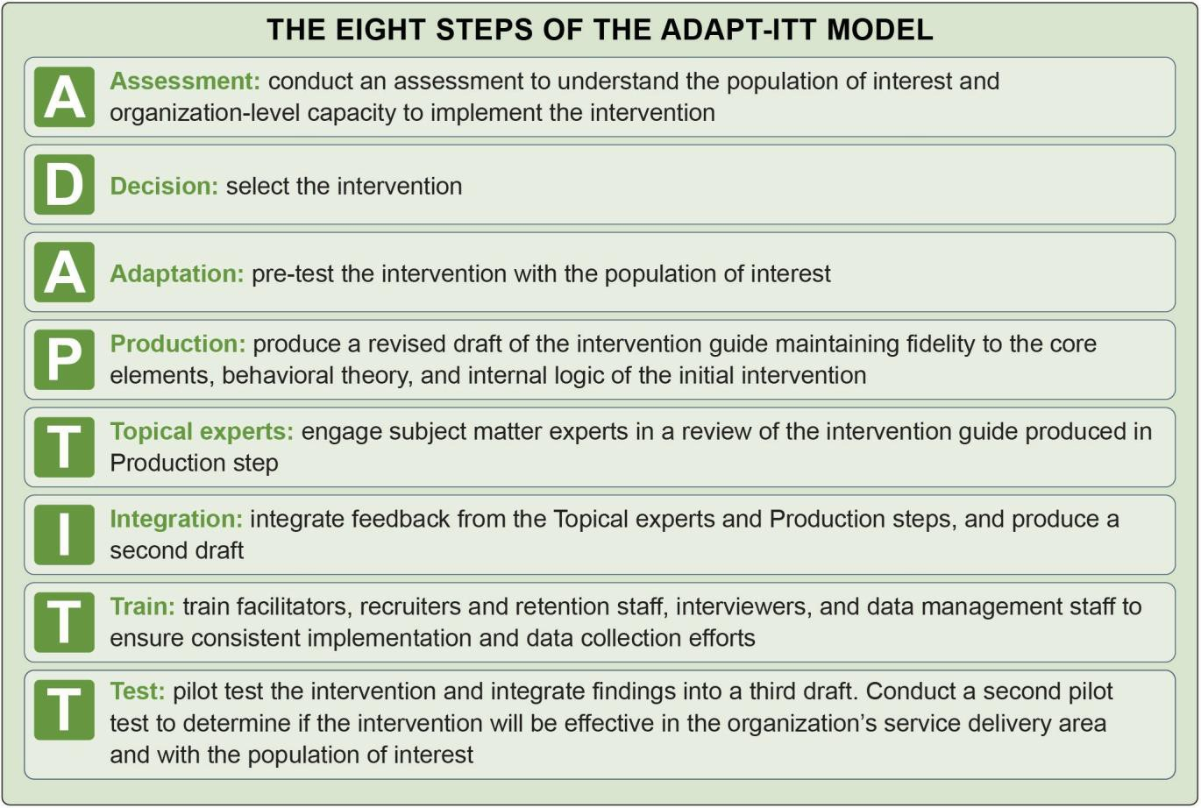


For programs that incorporate families into treatment, the practitioner will first need to ask the youth whether their parents know about their gender identity and/or sexual orientation. Second, if parents are aware, they will need to assess how the parents responded to this information and determine how the family is currently interacting around issues related to gender identity and/or sexual orientation. With this information in mind, clinicians can then implement interventions
to reduce suicidal thoughts and behaviors while ensuring they do not result in further stigmatization and rejection of gender and/or sexual minority youth by their families.
  - Consult Best Practices in Telehealth - Treating clients in-person is not always possible, especially in more rural regions that may have a shortage
of behavioral health practitioners and during public health emergencies, such as the COVID-19 pandemic. Virtual treatment approaches may be more accessible and cost-effective.

When adapting programs to be delivered virtually, program administrators should consult best practices in delivering telehealth services, such as the American Telemedicine Association’s Practice Guidelines for Video-
Based Online Mental Health Services,²⁰ in addition to following the ADAPT-ITT
framework or a similar model for adapting evidence-based programs. Clinicians should take extra precautions to ensure the safety of clients experiencing suicidal thoughts or behaviors when receiving treatment virtually. Strategies for ensuring safety include developing a plan
for how to contact emergency support while remaining on the line with the individual, asking for the client’s location at the outset of the treatment session, and staying on the line with the client until care arrives if risk is imminent.²¹ The interventions reviewed in this guide have not been evaluated with telehealth service delivery, and more research is needed to identify and address potential barriers and determine the effectiveness.

Treatment Adherence and Retention in Care
Consideration: The effectiveness of a program depends on the participant’s adherence to the recommended treatment plan and retention in care.

Strategies:

  - Engage youth as active partners in their own care - Practitioners should engage youth in collaborative treatment planning and goal setting and also engage
the family when appropriate. Everyone should agree to expectations and responsibilities for the clinician and the participant.

  - Assess adherence behaviors and potential barriers, such as low self- efficacy, stigma, financialconcerns, and access to services - Once barriers are identified, clinicians
should work with families to address immediate clinical concerns, such as low self-efficacy and stigma. Simultaneously, they can provide support to address other obstacles to care, including case management to access insurance, transportation
to services, and referrals to social services. Application of problem-solving skills training and/or motivational interviewing can be helpful strategies for the clinician to use.

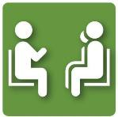
Build a therapeutic alliance by demonstrating positive regard for the youth and family, showing empathy, and communicating clearly - Research suggests
therapeutic alliance is a strong predictor of retention in treatment.²²

Program Sustainability
Consideration: Implementation of treatment programs requires sustainable funding mechanisms. Estimates
of implementation costs should include staff time and resources for planning, training, materials, technology needs, and service delivery. Clinicians may experience challenges receiving adequate reimbursement due to the longer duration of services needed to implement some of these interventions, as well as limited coverage for comprehensive components such as team-based care.

Strategies:
  - Review insurance policies - State Medicaid, the Children’s Health Insurance Program, and private insurance policies differ in
their requirements for reimbursement of behavioral health services, including diagnostic assessments, psychiatric care, psychotherapy, partial hospitalization programs, intensive outpatient programs, and family therapy.
Reimbursement policies can be confusing and complex. Program administrators should seek and provide clarification around common billing concerns, such as same-day billing restrictions and billing for family therapy when the client with the presenting problem (e.g., youth with suicidal thoughts) is not present.
  - Coordinate with state and local suicide prevention partners - State agencies and local organizations may have funding to provide training and technical assistance related to program implementation.²³⁻²⁴ For example, the Substance Abuse and Mental Health Services Administration supports state and local prevention efforts through the Garrett Lee Smith Suicide Prevention and the Zero Suicide grant programs.

Program Resources
In addition to the overarching implementation guidance provided above, several resources are available to help individuals and organizations implement the programs described in Chapter 2. Some of the programs have
not been widely disseminated or implemented. The list below provides a sample of available resources for each program.

Dialectical Behavior Therapy
SAMHSA’s Technology Transfer Center Network provides free training and resources on DBT.
DBT-Linehan Board of Certification oversees DBT certification and includes a directory of certified clinicians and programs. The site includes additional resources, such as book recommendations.
Psychwire offers online DBT training courses, free training videos, and a DBT newsletter.
Behavioral Tech, founded by the developer of DBT, Marsha Linehan, PhD, ABPP, provides comprehensive DBT information, categorizes global DBT research, and offers DBT training, certification, and consultation. The site also includes resources for children and families.
Treatment Implementation Collaborative offers DBT implementation assistance, as well as training, consultation, and supervision.

Attachment-Based Family Therapy
The ABFT Training Program at Drexel University’s Center for Family Intervention Science provides a variety of resources, including an ABFT treatment manual, trainings to achieve ABFT certification, webinars, supervisor and trainer trainings to help organizations build internal capacity for implementation, and a free ABFT Dissemination and Implementation Starter Packet.
The American Psychological Association offers an online introductory workshop on ABFT for a nominal fee.

Other Resources
MST Services, founded by the Multisystemic Therapy (MST) developers, provides ongoing implementation support for organizations. Supports available from MST Services and its network of partners include:
development of a process to track key outcomes, semiannual program reviews and problem solving support, centralized MST database for collection of therapist and supervisor adherence to model and youth clinical outcomes, initial 5-day orientation and quarterly booster trainings, weekly consultation with an MST expert and MST psychiatrist expert, and supplemental trainings for MST–Psychiatric programs. The website includes free videos, fact sheets, and webinars.
The UCLA-Duke Center for Trauma-Informed Adolescent Suicide, Self-Harm, and Substance Abuse Treatment and Prevention (ASAP Center) is part of the National Child Traumatic Stress Network. The ASAP Center offers information, trainings, and other resources for implementing Safe Alternatives for Teens and Youth (SAFETY) and SAFETY-Acute (SAFETY-A),
also referred to as Family Intervention for Suicide Prevention. Available resources include: free webinars; manuals; tip sheets with clinical guidance; standardized patient case demonstrations; other training materials and resources for implementing components of these programs; and information on the development and evidence base for SAFETY and SAFETY-Acute.
Information and resources can also be accessed through the Youth Stress & Mood Program within the
Department of Psychiatry at the University of California Los Angeles.
In this book chapter, the developers of I-CBT provide guidance on how to select treatment candidates for
I-CBT, and a case study example of how to implement I-CBT: Esposito-Smythers, C., Spirito, A., & Wolff, J. (2019). CBT for co-occurring suicidal behavior and substance use (I-CBT). In M. Berk (Ed.) Evidence- Based Treatment Approaches for Suicidal Adolescents:
Translating Science into Practice. American Psychiatric Publishing.
The Youth and Young Adult Depression and Suicide Prevention Research Program at the University
of Michigan’s Department of Psychiatry provides information and resources related to Youth-Nominated Support Team – Version II, including access to the free intervention manual.

Reference List

¹ Jacob, J. A., Jone, E., Gabella, B.A., Spring, B., & Brownson, R.C. (2012). Tools for implementing an evidence-based approach in public health practice. Preventing Chronic Disease, 9, 110324. http:// dx.doi.org/10.5888/pcd9.110324
² Suicide Prevention Resource Center. (2019). A strategic planning approach to suicideprevention. https://training.sprc.org/enrol/index.php?id=31
³ Fortney, J., Unützer, J., Wrenn, G., Pyne, J., Smith, G., Schoenbaum, M., & Harbin, H. (2017). A tipping point for measurement-based care. Psychiatric Services, 68(2), 179-188. https://doi.org/10.1176/ appi.ps.201500439
⁴ Achenbach System of Empirically Based Assessment. (2020). School-Age (CBCL, TRF, YSR, BPM/6-18). https://aseba.org/school-age/
⁵ Northwestern University. (2020). HealthMeasures. https://www.healthmeasures.net/
⁶ Brausch, A. M., O’Connor, S. S., Powers, J. T., McClay, M. M., Gregory, J. A., & Jobes, D. A. (2019). Validating the Suicide Status Form for the Collaborative Assessment and Management of Suicidality in a psychiatric adolescent sample.
Suicide and Life-Threatening Behavior, 50(1), 263-
276. https://doi.org/10.1111/sltb.12587
⁷ Stanley, B., Chaudhury, S. R., Chesin, M., Pontoski, K., Bush, A. M., Knox, K. L., & Brown, G. K. (2016). An emergency department intervention
and follow-up to reduce suicide risk in the VA: Acceptability and effectiveness. Psychiatric Services, 67(6), 680-683. https://doi.org/10.1176/ appi.ps.201500082
⁸ Brown, G., Stanley, B., Western Interstate Commission for Higher Education, & Suicide Prevention Resource Center. (2009). Safety planning guide: A quick guide for clinicians. Education Development Center, Inc. https://www.sprc.org/ resources-programs/safety-planning-guide-quick- guide-clinicians
⁹ Hughes, J. L., & Asarnow, J. R. (2013). Enhanced mental health interventions in the emergency department: Suicide and suicide attempt prevention in the ED. Clinical Pediatric Emergency
Medicine, 14(1), 28-34. https://doi.org/10.1016/j. cpem.2013.01.002

¹⁰ Suicide Prevention Resource Center. (2018). CALM: Counseling on access to lethal means. http://www. sprc.org/resources-programs/calm-counseling- access-lethal-means
¹¹ Stone, D. M., Holland, K.M., Bartholow, B., Crosby, A.E., Davis, S., & Wilkins, N. (2017). Preventing suicide: A technical package of policies, programs, and practices. Centers for Disease Control and Prevention. https://www.cdc.gov/violenceprevention/ pdf/suicideTechnicalPackage.pdf
¹² Donaldson, D., Spirito, A., & Boergers, J. (2010). Treatment engagement with adolescent suicide attempters. In D. Castro-Blanco & M. S. Karver (Eds.), Elusive alliance: Treatment engagement strategies with high-risk adolescents. (pp. 207-225). American Psychological Association.
¹³ Daniel, S. S., & Goldston, D. B. (2009). Interventions for suicidal youth: A review of the literature and developmental considerations. Suicide and Life-Threatening Behavior, 39(3), 252-268. https://doi.org/10.1521/suli.2009.39.3.252
¹⁴ Wu, P., Hoven, C. W., Liu, X., Cohen, P., Fuller,
C. J., & Shaffer, D. (2004). Substance use, suicidal ideation and attempts in children and adolescents. Suicide and Life-Threatening Behavior, 34(4), 408- 420. https://doi.org/10.1521/suli.34.4.408.53733
¹⁵ Wilczynski, S. M. (2017). Chapter 8 - Treatment feasibility and social validity. In S. M. Wilczynski (Ed.), A Practical Guide to Finding Treatments That Work for People with Autism (pp. 47-57).Academic Press. http://www.sciencedirect.com/science/article/ pii/B978012809480800008X.
¹⁶ Wingood, G. M., & DiClemente, R. J. (2008). The ADAPT-ITT model: A novel method of adapting evidence-based HIV Interventions. Journal
of Acquired Immune Deficiency Syndromes, 47(Suppl 1), S40-46. https://doi.org/10.1097/ QAI.0b013e3181605df1
¹⁷ Escoffery, C., Lebow-Skelley, E., Haardoerfer, R., Boing, E., Udelson, H., Wood, R., Hartman,
M., Fernandez, M. E., & Mullen, P. D. (2018). A systematic review of adaptations of evidence-based public health interventions globally. Implementation Science, 13(1), 125. https://doi.org/10.1186/s13012-
018-0815-9

¹⁸ Bernal, G., Chafey, M., & Domenech Rodríguez, M. (2009). Cultural adaptation of treatments: A resource for considering culture in evidence-based practice. Professional Psychology: Research and Practice, 40, 361-368. https://doi.org/10.1037/a0016401
¹⁹ Society forAdolescent Health and Medicine. (2013). Recommendations for promoting the health and well-being of lesbian, gay, bisexual, and transgender adolescents: A position paper of the Society for Adolescent Health and Medicine. Journal of Adolescent Health, 52(4), 506-510. https://doi. org/10.1016/j.jadohealth.2013.01.015
²⁰ American Telemedicine Association. (2009). Practice guidelines for video-based online mental health services. https://www.americantelemed. org/resources/practice-guidelines-for-video-based- online-mental-health-services-2/
²¹ Center for Practice Innovations at Columbia Psychiatry New York State Psychiatric Institute, & SP-TIE: Suicide Prevention-Training
Implementation Evaluation. (2020). Telehealth tips: Managing suicidal clients during the COVID-19 pandemic. http://zerosuicide.edc.org/sites/default/ files/Telehealth%20Tips%20with%20Suicidal%20 Clients%20-%20FINAL.pdf
²² Dunster-Page, C., Haddock, G., Wainwright, L., & Berry, K. (2017). The relationship between therapeutic alliance and patient’s suicidal thoughts, self-harming behaviours and suicide attempts: A systematic review. Journal of Affective Disorders, 223, 165-174. https:// doi.org/10.1016/j.jad.2017.07.040
²³ Suicide Prevention Resource Center. (2020). States. https://www.sprc.org/states
²⁴ Suicide Prevention Resource Center. (2020).
Grantees. https://www.sprc.org/grantees


CHAPTER
4

Examples of Suicide Treatment Programs

This chapter highlights two examples of organizations that provide treatment services to address suicidal ideation, self-harm, and suicide attempts among youth. Each organization is implementing an intervention with strong or moderate support for causal evidence detailed in Chapter 2, including:
- Dialectical Behavior Therapy (DBT)
- Attachment-Based Family Therapy (ABFT)
The chapter documents how each setting has implemented these treatment programs as part of a comprehensive strategy to address the needs of their populations. Programs should implement interventions with fidelity to evaluated models. Fidelity is the degree to which a program delivers a practice as intended
and must be maintained for desired therapy outcomes. However, many programs, including those highlighted in this chapter, adapt chosen interventions to better serve their clients. As clinical providers and program administrators modify these interventions to address the needs and constraints of their population, budget,
setting, and other local factors, they should adhere to the evidence-based program’s foundational principles and core components.
The two examples highlighted in this chapter were identified through an environmental scan and in consultation with subject matter experts. While there are additional programs that could have been featured in this chapter, the programs described below are considered

representative examples of current adaptations of evidence-based treatment protocols for suicidal thoughts and behaviors and serve diverse populations of youth.
The examples detailed in this chapter:
- Include interventions identified in Chapter 2
- Can be replicated (are well-defined with guidance materials or a manual)
- Have preliminary evaluation data to show promise of impact on suicide-related outcomes
- Exemplify implementation in varying
geographic areas, practice settings, and diverse populations



Indian Health Service – Desert Visions and Nevada Skies Youth Wellness Centers
Sacaton, Arizona and Wadsworth, Nevada

Desert Visions and Nevada Skies are residential treatment centers for American Indian/Alaska Native (AI/AN) youth aged 12 to 18. About one-third of youth present at intake with suicidal ideation or behavior. The centers offer a multi-disciplinary treatment approach that includes biopsychosocial, health, education, and cultural activities.
DBT-A is the primary treatment modality, with adaptations to incorporate cultural and spiritual practices, including talking circles, sweat lodges, smudging, and drumming.¹ In addition, a Native American traditional spiritual counselor comes from the community weekly to provide traditional acupuncture and medicinal preparations.
The centers are owned and operated by the Indian Health Service (IHS), with about half of funding for the DBT-A program from the federal government and half from billing to private insurance plans.

Model Features and Elements
  - Manualized (Rathus & Miller, 2014) 16-week DBT-A program is operated alongside with traditional healing practices.
  - Youth receive individual therapy weekly, group
therapy daily, and family therapy at least twice monthly.
  - Family therapy is an integral part of treatment
and takes place in-person when the family is located close to the facility or virtually if in- person meetings are not possible. However, multifamily skills groups have not been implemented due to feasibility issues in the residential setting.
  - The centers employ full-time medical staff, 24- hour nursing support, and a medical director.
  - All counselors (primarily master’s level)
complete a two-week intensive DBT training and receive weekly consultation.
  - Training in the originally developed DBT
(for adults) is readily available and provides a foundation for implementing DBT-A. Following

Program Implemented
Dialectical Behavior Therapy for Adolescents (DBT-A)
Setting
Two residential treatment centers serving AI/AN youth aged 12 to 18 for a minimum of 120 days.
Population of Focus
AI/AN youth with a primary diagnosis of substance use disorder. Most youth have co- occurring diagnoses of depression, anxiety, eating disorders, serious mental illness, or conduct disorders.
Program Duration
Youth receive the 16-week DBT-A program as part of their residential stay of at least 120 days.
Related Resources
Program Website

the two-week DBT training, counselors receive training specific to implementation with adolescents.
  - Counselor aides and nursing staff also participate in DBT training.
  - DBT mindfulness module incorporates cultural
and spiritual practices, such as talking circles, sweat lodges, and smudging.
  - Safety planning is conducted with youth at risk
of harming themselves or others.
- Empirically supported, standardized measures
are administered throughout the program.
  - Columbia-Suicide Severity Rating Scale,² Youth Outcome Questionnaire-SR (YOQ-SR),³ and the Linehan Risk Assessment and Management
Protocol (LRAMP)⁴ are administered at program entry. All three measures include assessment of suicidal risk.

  - YOQ-SR is re-administered every two weeks and before discharge, and LRAMP is re- administered when clinically indicated, for example if youth expresses suicidal ideation or engages in self-harm.
  - Youth can serve in a leadership role as peer mentors, which includes orienting new clients to the program.

Findings and Outcomes
Desert Visions reports positive outcomes related to:
  - Treatment completion
  - Improved delivery and coordination of care by all staff
  - Improved ability by the adolescents to utilize
skillful/effective behavior instead of self- destructive/harmful behavior
In a pilot study of 229 participants, 96 percent had statistically significant changes on the YOQ-SR.⁵ The YOQ-SR asks specifically about self-harm and suicidal ideation, in addition to emotional and physical distress and interpersonal problems.

Lessons Learned

  - It is possible to integrate traditional, spiritual, and cultural practices seamlessly into DBT-A.
  - In a residential setting, it is critical that the
frontline staff, who spend the most time with youth, are trained in DBT-A at the same level as the counselors and other staff. With this training, frontline staff can provide real-time coaching of skills. This is a critical part of strengthening skill acquisition and also generalizing the skills to multiple settings.
  - Follow-up training and ongoing support systems for staff, such as weekly team meetings, improve job satisfaction and reduce burnout.⁶
  - DBT case consultation is essential to ensure
that therapists and staff maintain fidelity to the DBT-A model.
  - Therapists and staff may benefit from aone-time training in the basics of behavior therapy, such as the concepts of reinforcement, extinction, and contingency management.

Central Toronto Youth Services – Outpatient Family Therapy
Toronto, Ontario

Central Toronto Youth Services (CTYS) is a community mental health center serving youth aged 12 to 24 and their families through in-office and outreach programs— including home- and school-based services—and individual, family, and group counseling. School-aged youth are often referred by schools when they would benefit from more support than their school social workers can provide.
ABFT is offered to youth with a variety of clinical presentations, including concerns about suicidal thoughts or self-harm. Programming is tailored to specific groups. For example, a program specifically for Black youth acknowledges the role of systemic racism and helps youth reconnect with their identity and culture.
CTYS also offers programming specific to the needs of lesbian, gay, bisexual, transgender, queer, or questioning youth, and youth with other sexual and gender minority identities (LGBTQ+). Services recognize the impact
of systemic oppression for these youth on their mental health.⁷ Youth are welcomed for individual sessions intended to prepare for family sessions. Parents and caregivers receive education and counseling around sexual orientation and/or gender identity, including through a support group for families in the process of accepting their youth’s sexual orientation and/or gender identity.
CTYS has worked with the ABFT developers at Drexel University to implement ABFT, and new family-focused workers attend ABFT Level 1 training through Drexel. ABFT developers provide monthly consultation.

Model Features and Elements
  - ABFT staff are graduate-level social workers, marriage and family therapists, or counselors.
  - CTYS has made some adaptations to ABFT to
meet the needs of LGBTQ+ youth; for example, parents may not be included in the youth’s therapy sessions until it is safe for the youth.
Often there is a repair session that needs to occur regarding parents’ reaction to their youth coming

Program Implemented
Attachment-Based Family Therapy (ABFT) Setting
Community mental health center, funded by the Ontario Ministry of Health.
Population of Focus
Youth aged 12 to 24 served throughout agency; some programs have specific age ranges or are targeted to specific groups, such as LGBTQ+ youth.
Program Duration
Youth participate in ABFT for an average of 18 months.
Related Resources
Program Website

out to them. Parents also learn about micro- aggressions and the ways in which they may be inadvertently rejecting their child’s sexual orientation and/or gender identity.
- CTYS provides adaptations for youth
with serious mental disorders that include psychoeducation, as well as more intensive case management, to help youth gain independence.
- Staff receive Applied Suicide Intervention Skills Training (ASIST), a suicide first aid program that addresses suicidal ideation and mitigates risk.⁸ ASIST training prepares staff to discuss suicide in a direct manner with someone at risk, to develop a safety plan, to encourage seeking further help as needed, and to encourage safe community involvement.⁹
- Therapists have low caseloads (12 to 15 families) to allow them to meet with youth individually, as well as accommodate all family members’ schedules for family sessions.
- A tip sheet is available for staff to help them have difficult conversations about suicide with youth and parents and to create a safety plan.

  - Through a safety plan, youth are empowered to cope with distress without automatically going to the hospital. An essential part of the safety plan is the crisis plan, for when coping skills are not sufficient to ensure safety.
  - Youth can take on leadership roles through a Youth Engagement Program.

Findings and Outcomes
The program uses the Child & Adolescent Functional Assessment Scale (CAFAS) to monitor clinical outcomes. The CAFAS assesses youth functioning at home, in school, and in the community. It also identifies concerns related to antisocial behavior, mood, thought patterns, substance use, and self-harm.¹⁰ In 2018, participants had an average drop of 25 points on the CAFAS following treatment. A decrease of 20 points or more is considered a clinically meaningful improvement.¹¹

Lessons Learned
  - Parents may have a history of trauma or neglect themselves. ABFT’s psychoeducation materials offer resources to help parents examine
the impact of their own stressors and intergenerational history
of trauma to understand their own parenting behaviors towards their children.
  - Responsibility is shared among the family, as opposed to focused on just the youth.
  - In a diverse community, such as Toronto,
some words in the program materials were adapted to be responsive to how parents are attuned with their children in other cultures, specifically for families with intergenerational care arrangements. For example, youth may have been parented by a grandparent who may be included in family sessions through video conference.
- Family therapy for LGBTQ+ youth is appropriate
for affirming and somewhat supportive parents. It is not an included service when parents have not affirmed their child’s sexual orientation and/ or gender identity. CTYS uses a reflection tool at the beginning of the program to better understand how well the parent understands the youth’s sexuality and gender identity. In addition, every youth is asked their pronouns and gender identity when beginning services.
- Therapists need regular peer or individual supervision around the nuances of family therapy to attend to the needs of everyone in the room.



Reference List

¹ Substance Abuse and Mental Health Services Administration. (2018). Behavioral health services for American Indians and Alaska Natives. Treatment Improvement Protocol (TIP) Series 61. https://store. samhsa.gov/sites/default/files/d7/priv/tip_61_aian_ full_document_020419_0.pdf
² The Columbia Lighthouse Project. (2016). About the protocol. https://cssrs.columbia.edu/the-columbia- scale-c-ssrs/about-the-scale/
³ OQ Measures. (n.d.). Y-OQ 2.0. https://www. oqmeasures.com/y-oq-sr-2-0/
⁴ Harned, M. S., Lungu, A., Wilks, C. R., & Linehan,
M. M. (2017). Evaluating a multimedia tool for suicide risk assessment and management: The Linehan suicide safety net. Journal of Clinical Psychology, 73(3), 308-318. https://doi.org/10.1002/ jclp.22331
⁵ Beckstead, D. J., Lambert, M. J., DuBose, A. P., & Linehan, M. (2015). Dialectical behavior therapy with American Indian/Alaska Native
adolescents diagnosed with substance use disorders: Combining an evidence based treatment with cultural, traditional, and spiritual beliefs. Addictive Behaviors, 51, 84-87. https://doi.org/10.1016/j. addbeh.2015.07.018
⁶ National Indian Health Board. (n.d.). Desert Visions Youth Wellness Center. https://www.nihb.org/ behavioral_health/mspi_program_desert_visions.php
⁷ Central Toronto Youth Services. (2020). Pride & Prejudice. https://ctys.org/program/pride-prejudice/
⁸ LivingWorks. (n.d.). LivingWorks ASIST. https:// www.livingworks.net/asist
⁹ Suicide Prevention Resource Center. (2007). Applied suicide intervention skills training (ASIST). https:// www.sprc.org/resources-programs/applied-suicide- intervention-skills-training-asist
¹⁰ Functional Assessment Systems. (2020). Child and Adolescent Functional Assessment Scale - CAFAS. http://www2.fasoutcomes.com/Content. aspx?ContentID=12
¹¹ Central Toronto Youth Services. (2018). Central Toronto Youth Services (CTYS): Our annual report 2017-2018. https://ctys.org/wp-content/uploads/ CTYS_Annual_Report_2017-2018_Rev_10.26_ Email.pdf



Evaluating an intervention can answer critical questions, provide information about how well a program has
5CHAPTER
Resources for Evaluation and Quality Improvement
been implemented, and determine what may or may not working. Evaluation can also show how programs benefit clients overall, including impacts on suicidal thoughts and behaviors. Evaluation data can also be helpful
in making program adjustments, justifying program continuation, and securing funding by providing evidence of program effectiveness. In addition, stakeholders can use information gathered via evaluation to encourage implementation interventions in other settings or communities.
This chapter provides an overview of approaches to evaluate implementation and results of programs that treat suicidal ideation, self-harm, and suicide attempts among youth. The chapter also includes information on implementing a continuous quality improvement (CQI) process and concludes with specific evaluation resources and potential suicide and suicide-related outcomes to track.

Types of Evaluations and Study Designs
Evaluation is typically conducted before a practice is implemented to determine its feasibility (formative evaluation), during implementation (process evaluation), and after the intervention has been delivered to at least one client (outcome and impact evaluations). All four types of evaluations are necessary to be able to make judgments about an intervention’s effectiveness on reducing suicidal thoughts and behaviors.
Although often overlooked, formative evaluation
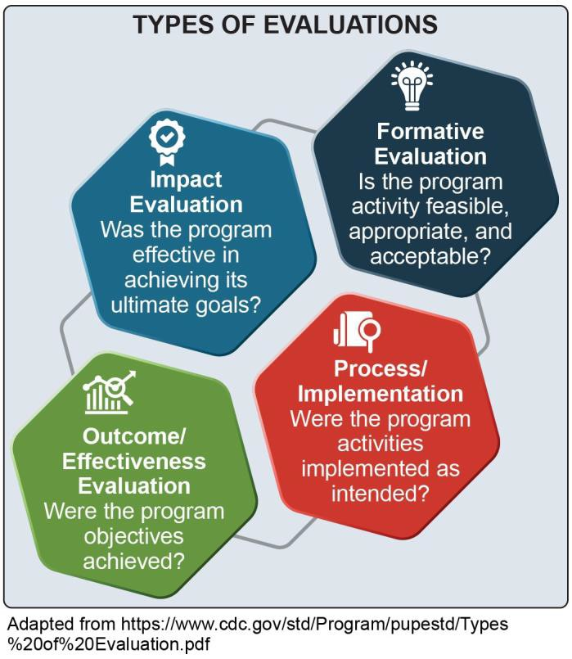
is an integral part of the implementation process and should be conducted when an organization is exploring the feasibility of implementing a suicide treatment program. This type of evaluation assesses readiness of an organization and its staff to implement the program, articulates a theory of change, and determines the extent to which a program can be evaluated in a reliable and credible fashion. During the formative evaluation,

Adapted from http://www.cdc.gov/std/Program/pupested/Types
%20of%20Evalution.pdf

program managers and clinicians also establish a way of collecting or obtaining data on program implementation, outcomes, and impact on suicide-related indicators.
The final product of formative evaluation is a written implementation and evaluation plan.
Process or implementation evaluation collects data about program implementation. It enables program managers and clinicians to assess whether a program was implemented as planned and informs program improvements. For example, the process evaluation might consist of qualitative interviews or surveys with clinicians and/or youth and their families to assess their satisfaction with the program. A process evaluation is also important for multi-component interventions to better understand if all components are being delivered by the clinicians and similarly attended by clients. For instance, reviewing the clinic records might indicate that the individual and group sessions have good retention, but the family sessions are less well-attended.

An outcome evaluation might assess a client’s attitudes toward treatment and help-seeking and/or reasons for living pre- and post- intervention; whereas an impact evaluation might focus on health system data to examine potential decreases in re-attempt rates or emergency department visits for suicide.

Outcome evaluations collect baseline data from clients on outcomes of interest that can be compared with
data collected at the program’s end. These outcome data provide program managers and clinicians with information to assess changes or improvements in client
attitudes and behaviors that can be associated with a new program.
Impact evaluations assess a program’s effectiveness in achieving its ultimate goals. Impact evaluations determine the extent to which changes in outcomes can be attributed to the new program.

Data Used for Evaluations
Evaluations use a variety of data to assess the impact of interventions. Qualitative and quantitative data are
complementary, and each provides critical insight into if and how the youth suicide intervention is operating and achieves the intended objectives.
Qualitative data include any non-numeric, text-based information, such as verbal, visual, or written data.
Qualitative data collection methods include interviews, focus groups, observations, gathering data from documents and images, and open-ended survey questions and polling responses.
Quantitative data are any numeric data that can be processed by mathematical or statistical analysis.
Quantitative data collection includes close-ended survey questions and polling responses, services and utilization data, and claims and encounter data.

Qualitative and quantitative research enables managers and clinicians to learn from clients and obtain the perspective of those with lived experiences. They also can involve collecting data from staff using the suicide
treatment program to obtain their perspective on facilitators and challenges to implementation.

Continuous Quality Improvement (CQI)
The U.S. Department of Health and Human Services (HHS) defines CQI as, “the systematic process of identifying, describing, and analyzing strengths and problems and then testing, implementing, learning from, and revising solutions.”
Most of the interventions discussed in this guide have multiple components, making CQI an important tool for an organization focusing on suicide prevention. CQI is an essential process for successfully implementing a program.

What is CQI?

CONTINUOUS QUALITY IMPROVEMENT (CQI)

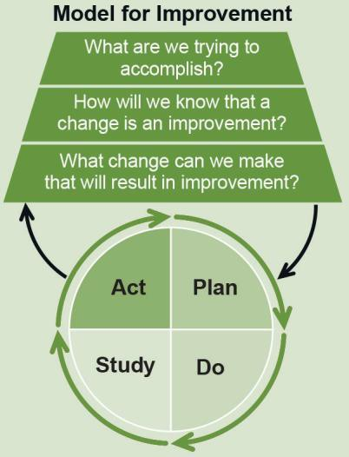CQI involves a systematic process of assessing program or practice implementation and short-term outcomes and then involving program staff in identifying and implementing improvements in service delivery and organizational systems to achieve better treatment outcomes. CQI helps assess practice fidelity, the degree to which a program delivers a suicide intervention as intended.
CQI differs from process evaluation in that it involves quick assessments of program performance, timely identification of problems and potential solutions, and implementation of small improvements to enhance treatment quality. CQI is usually conducted by internal staff. Process evaluation involves longer-term assessments and is best conducted by an external evaluator.
The Institute for Healthcare Improvement’s PDSA Model for Improvement identifies a scientific method for testing small-scale changes in an action-oriented, cyclical manner. The stages are: planning it (Plan), trying it (Do), observing the results (Study), and acting on what is learned (Act).
Why use CQI?
CQI takes a broader look at the systems in which programs or practices operate. Because of the pivotal role it plays in performance management, organizations treating individuals with suicidal thoughts and behaviors are encouraged to implement CQI procedures.
What are the steps involved in CQI?
Although steps in the CQI process may vary based on objectives, typical CQI steps are:
- Identify a program or practice issue needing
- improvement and a target improvement goal
- Analyze the issue and its root causes
- Develop an action plan to correct the root causes
- Implement the actions in the action plan
- Review the results to confirm that the issue and its root causes have been addressed and short-term and long-term treatment outcomes have improved
- Repeat these steps to identify and address other issues as they arise

Institute for Healthcare Improvement. (n.d.). Science of Improvement: Testing Changes.
http://www.ihi.org/resources/Pages/HowtoImprove/ScienceofImprovementTestingChanges.aspx
New Jersey Department of Children and Families. (n.d.). CQI Framework: Five Stages of Continuous Quality Improvement.
https://www.nj.gov/dcf/about/divisions/opma/cqi.html
Office of Adolescent Health. (n.d.). Continuous Quality Improvement, Part 1: Basics for Pregnancy Assistance Fund Programs. U.S. Department of Health & Human Services.
https://www.hhs.gov/ash/oah/sites/default/files/cqi-intro.pdf

Outcomes
One of the final important, but often challenging, steps in the process of implementing programs is to determine whether they have yielded desired outcomes. An outcome is the change a program plans to accomplish through the implementation of a practice.
The table below provides a list of potential outcomes, illustrative outcome indicators, and data sources that program managers, practitioners, and others may use to evaluate practices to reduce suicidal ideation, self- harm, and suicide attempts. Many of these short- and
intermediate-term outcomes may be tracked at baseline and throughout the practice or program duration through an electronic health record. Longer-term outcomes may be obtained from administrative and survey data.
If an organization wants to understand the prevalence or epidemiology of suicide in a particular state or region, it may be helpful to review national surveillance data sources, such as the Center for Disease Control and Prevention’s Youth Risk Behavior Surveillance System.

Outcome | Illustrative Indicators | Illustrative Data Sources
Short-term Outcomes
Implementation of evidence- based treatment programs | - Number of providers trained to implement evidence-based programs  - Number of providers reporting use of the programs  - Perception among providers that program is suitable for organization and client population | - Administrative data on training  - Surveys/interviews of providers  - Organizational surveys on practice change (e.g., Program Sustainability Assessment Tool)
Program fidelity | - Degree to which program is implemented as intended | - Surveys/interviews of providers  - Observation checklists
Treatment initiation | - Number of youth initiating treatment with new program/practice | - Attendance/administrative data
Intermediate Outcomes
Improved treatment engagement and adherence | - Extent of client engagement in the recommended treatment regime (e.g., session attendance, premature termination) | - Attendance/administrative data  - Youth and family satisfaction surveys
Change in severity of mental health concerns | - Measures of clinical depression, substance use, antisocial behavior, etc. | - Client self-report qualitative data  - Structured clinical interview  - Standardized scales administered by clinician (e.g., Patient Health Questionnaire, Teen Addiction Severity Index)
Improved skills associated with coping and help-seeking behaviors | - Engagement with supportive adults at home, at school, and in the community  - Use of coping skills outside of treatment sessions | - Client self-report qualitative data
Reduced incidence of suicidal thoughts or behaviors | - Measures of suicidal ideation and self-harm  - Reduced Emergency Department visits and hospitalizations | - Client self-report qualitative data  - Structured clinical interview  - Standardized scales administered by clinician (e.g., Columbia Suicide Severity Rating Scale, Harkavy-Asnis Suicide Survey)  - Electronic health record data

Long-term Outcomes and Impacts
Extent to which program is maintained over time | - Rates of program completion  - Funding stability for program | - Electronic health record data  - Organizational surveys on practice change
Reduction in suicidal ideation rates | - Rates of suicidal ideation | - Electronic health record data
Reduction in self-harm rates | Rates of:  – Non-suicidal self-injury  - Self-harm (intent unknown) | - Electronic health record data
Reduction in fatal and nonfatal suicide attempt rates | Rates of:  - Reported attempts  - Emergency Department visits  - Hospitalizations due to suicide attempts | - Electronic health record data

Evaluation Resources
The following section includes guides and resources to support program evaluation and quality improvement. Organizations may consider partnering with academic institutions or local program evaluation experts for external evaluation services or for assistance building internal evaluation capacity.

Evaluating Program Implementation
  - A Framework for Program Evaluation from the Program Performance and Evaluation Office at the Centers for Disease Control and Prevention (CDC) summarizes essential elements of program evaluation.
  - Suicide Prevention Program Evaluation Toolkit from The RAND Corporation helps program staff overcome challenges to evaluating and planning improvements to their programs.

Evaluating Client-Level Outcomes and Population-Level Prevalence
  - Healthy Measures includes PROMIS® and the NIH Toolbox®, two free comprehensive sets of neuro- behavioral measurements that assess a broad range of symptoms and risk and resiliencefactors.
  - Suicide Prevention Resource Center’s Locating and Understanding Data for Suicide Prevention Online Course provides an overview of the strengths and limitations of data on suicide deaths, key suicide data sources, and an explanation of how to use the data to inform community partners and policymakers.
  - Suicide Prevention Resource Center’s directory of state-specific resources includes contact information for state suicide prevention directors and suicide prevention strategic plans.
  - CDC’s Youth Risk Behavior Surveillance System is a national survey that measures the prevalence of risk behaviors among students in grades 9 through 12, including suicidal ideation and suicide attempt.
  - CDC’s WISQARS™ (Web-based Injury Statistics Query and Reporting System) is an interactive, online database that provides fatal and nonfatal injury, including self-harm and suicide, and cost of injury data from a variety of trusted sources.

Quality Improvement and Continuous Performance Monitoring
  - Zero Suicide’s Data Elements Worksheet is intended to assist health and behavioral
healthcare organizations in developing a data- driven, quality improvement approach to suicide care.
  - Institute for Healthcare Improvement’s Quality Improvement Essentials Toolkit includes
the tools and templates to launch a quality improvement project and manage performance improvement.

Resources for Evaluating Programs in Native American and Alaska Native (AN/AI) Communities
  - The Administration for Children and Families’ A Roadmap for Collaborative and Effective Evaluation in Tribal Communities provides NA/ AI values and priorities, knowledge of which can enhance trust between tribal programs and their evaluation partners and other stakeholders.

Appendix 1: Acknowledgments

This publication was developed with a significant contribution from Mary Cwik, PhD and Leigh Fischer, MPH. The guidance is based on the thoughtful input of SAMHSA staff and the Expert Panel on Treatment for Suicidal Ideation, Self- Harm, and Suicide Attempts Among Youth from October 2019 through September 2020. A series of guide development meetings was held virtually over a period of several months. Three expert panel meetings were convened during this time.

SAMHSA Staff

Christine Cichetti
National Mental Health and Substance Use Policy Laboratory

Thomas Clarke, PhD
National Mental Health and Substance Use Policy Laboratory

Steven Dettwyler, PhD*
Center for Mental Health Services

Daniel Gallardo, MPH*
National Mental Health and Substance Use Policy Laboratory

Tanya Geiger, PhD, MPH*
National Mental Health and Substance Use Policy Laboratory

Donelle Johnson, PhD, MHSA*
National Mental Health and Substance Use Policy Laboratory

Richard McKeon, PhD, MPH
Center for Mental Health Services

Expert Panel

Joan Asarnow, PhD
University of California, Los Angeles

Mary Cwik, PhD*
Johns Hopkins University

Kelly Davis
Mental Health America

Christianne Esposito-Smythers, PhD
George Mason University

David Goldston, PhD
Duke University

Mike Hogan, PhD
Hogan Health Solutions, LLC

Cheryl King, PhD
University of Michigan

Michael Lindsey, PhD, MSW, MPH
New York University

Stephen O’Connor, PhD
National Institute of Mental Health

Mary Rooney, PhD
National Institute of Mental Health

Morton Silverman, MD
Suicide Prevention Consultant

Anthony Spirito, PhD
Brown University

Deborah Stone, ScD, MSW, MPH
Centers for Disease Control and Prevention

Brian Thoma, PhD
University of Pittsburgh

Contract Staff

Katherine Armstrong, AB
Abt Associates
Leigh Fischer, MPH* Abt Associates
Margaret Gwaltney, MBA* Abt Associates

Caroline Kupersmith, BA
Abt Associates

Cayla Roby, MA, MPH
Abt Associates
Sarah Steverman, PhD, MSW* Abt Associates

Brandy Wyant, MPH, MSW, LCSW
Abt Associates

Daniel Jefferson Smith
Abt Associates

Korrin Bishop, BS
Korrin Bishop Writing & Editing

*Members of the Guide Planning Team

The authors followed a rigorous, systematic evidence review process in the development of this guide. This appendix provides an overview of the evidence review methodology used to identify the ratings for the programs included in the guide. Reviewers, in coordination with SAMHSA and experts, conducted a four-step process to select programs, identify related studies, review and rate studies, and identify program ratings.

Step 1: Program Selection
The authors identified six programs after a review of the literature and in consultation with experts. To include interventions that would be most useful to those treating suicidal ideation, self-harm, and suicide attempts, eligible programs were required to meet the following criteria for evidence review:
  - Be clearly defined and replicable
  - Address the target outcome of reducing suicidal thoughts and behaviors
  - Be currently in use
  - Have studies of their effectiveness
  - Have accessible implementation and fidelity supports
At the conclusion of this step, SAMHSA and theguide’s Expert Panel reviewed the proposed programs identified by the authors and agreed on six for inclusion in the evidence review and rating process. Ultimately two were given ratings and four were deemed promising but requiring further study.

Step 2: Study Identification
Once the programs were selected, the reviewers conducted a comprehensive review of published research on these programs to identify studies of the selected programs. This review only included studies from eligible sources (i.e., peer-reviewed journals and government reports) that avoid clear conflicts of interest. The reviewers documented all potential studies identified through the literature search.
The studies identified in the literature search varied in type and rigor, so the reviewers assessed them further for inclusion in the evidence review. To be eligible for review and study rating, research studies had to:
  - Employ a randomized or quasi-experimental design, or
  - Be a single sample pre-post design or an epidemiological study with a strong
counterfactual (a study that analyzes what would have happened in the absence of the intervention).
Literature reviews, descriptive reports, implementation studies, and meta-analyses were not included in the review, but were documented to provide context and identify implementation supports for the programs.
Additionally, to be eligible for further review and rating, studies had to:
  - Be published or prepared in or after 2000
  - Be a publicly available peer-reviewed or research report
  - Be available in English
  - Include at least one eligible outcome related to reduced suicidal thoughts and behaviors
  - Have a comparison/control group that is treatment as usual, or no/minimal intervention if using a randomized experimental or quasi- experimental design

Step 3: Study Review and Rating
Next, trained reviewers assessed each study to ensure the methodology was rigorous and therefore could demonstrate causation between the programs and
the identified outcomes. Reviewers reviewed and documented each study to ensure:

- Experimental and comparison groups were statistically equivalent, with the only difference being that participants in the experimental group received the intervention and those in the comparison group received treatment as usual or no/minimal intervention.
- For randomized experiments with high attrition and for quasi-experimental designs, baseline equivalence was established between the treatment and comparison groups.
- For randomized experiments, randomization was not compromised. For example, ensuring that reassignment of treatment status, usually made to balance the distribution of background variables between treatment and control groups, did not occur.
- Study did not have any confounding factors (factors that affect the outcome but are not accounted for by the study).
- Missing data were addressed appropriately:
  - Imputation based on surrounding cases was considered valid.
  - Complete case analysis was considered valid and accounted for as attrition.
  - Using model with dummy for missing as a covariate was considered valid.
  - Assuming all missing data points are either positive or negative was not considered valid.
  - Regression-based imputation was considered valid; mean imputation was not considered valid.
- Outcome measures were reliable, valid, and collected consistently from all participants.
- Valid statistical models were used to estimate impacts.
- Program demonstrated improved outcomes related to suicidal thoughts and behaviors.
Based on the study design and these study characteristics, reviewers gave each study a rating for causal impact. Reviewers used the following scoring metric for each study, based on the eight factors above, to determine if a study rated:
  - High support of causal evidence
  - Moderate support of causal evidence
  - Low support of causal evidence
Only randomized controlled trials, quasi-experimental designs, and epidemiological studies with a strong comparison were eligible to receive a high or moderate study rating.

Step 4: Program Rating
After all studies for a program were assessed for these criteria, the reviewers gave each program a rating based on the number of studies with strong, moderate, or emerging support of causal impact. Causal impact is evidence demonstrating that an intervention causes, or is responsible for, the outcome measured in the study’s sample population.
The program was placed into one of the following categories based on the level of causal evidence of its studies:
- Strong Evidence - Causal impact demonstrated by at least two randomized controlled trials, quasi-experimental designs, or epidemiological studies with a high or moderate rating.
- Moderate Evidence - Causal impact demonstrated by at least one randomized controlled trial, quasi-experimental design, or epidemiological study with a high or moderate rating.
- Emerging Evidence - No study received a high or a moderate rating. The program may have been evaluated with less rigorous studies (e.g., pre-post designs) that demonstrate an association between the program and positive outcomes, but additional studies are needed to establish causal impact.
The four-step process described above resulted in identification and rating of two programs with evidence for treating suicidal thoughts and behaviors. The rating given to each program is intended to inform decision- making about adoption of new practices or clinical or system enhancements that will improve outcomes for youth.



Photos are for illustrative purposes only. Any person depicted in a photo is a model.

Publication No. PEP20-06-01-002 Released 2020

SAMHSA’s mission is to reduce the impact of substance abuse and mental illness on America’s communities.
1-877-SAMHSA -7 (1-877-726-4727) 1-800-487-4889 (TDD) www.samhsa.gov

