/ www.samhu.gov • Hl77-SAMHSA-7 (1-877-726-4727)
,SAMHSA
I!
,,, r,EK.
Recovery-Oriented Systems of Care (ROSC) Resource Guide

September 201 0

for recovery

Table of Contents
Introduction 1
ROSC in the New Health Care Environment 2
History of ROSC 6
Recovery Support Services (RSS) 7
Role of Recovery Management 10
What Is Happening Around the Country? 12
California 12
North Carolina 12
Vermont 13
Planning and Implementation Steps 15
Additional ROSC Resources 25
Additional Health Care Reform Resources 25
Summary 27

Introduction
Are you looking for resources on resiliency and recovery-oriented systems of care (ROSC)? Further, have you been reading the headlines concerning national health care reform and wondering how it will impact programs and services within a ROSC? This guide, which contains information from the Substance Abuse and Mental Health Services Administration (SAMHSA), and your colleagues around the country, will assist you with answers to these questions. State and local policy makers responsible for substance use programming, as well as providers of treatment and recovery support services, can look to this guide for information to enhance prevention, treatment, and recovery services as the changes in health care evolve in their communities.
The purpose of this resource guide is to share an overview of ROSC and illustrate how these systems are an integral part of the new health care environment. This guide will align the tenets of health care reform to the benefits, framework, and history of ROSC, and the steps for planning and implementing ROSC. Following each section of the guide’s narrative, you will find websites to direct you to specific resources that will assist you in conceptualizing and developing ROSC. The resources in this guide include research studies, white papers, conference presentations, manuals, practice guides, check lists, regulations and a number of other documents that have been prepared in response to the need for systems reform.
The establishment of ROSC is a relatively new concept in the substance use disorder field. The structure of ROSC will likely evolve as these systems mature and are evaluated. However, as States and communities are creating and implementing ROSC, they can learn from one another. At the same time that they are developing ROSC, they must also consider the changes that are occurring as a result of health care reform. Some policy makers and providers have begun to assess their community strengths and needs in this regard and formulate ROSC plans that are compatible with the tenets of national health care reform. We hope this resource guide will assist with that process.
One of the most important elements of national health care reform is the expansion of coverage for those with substance use and mental health disorders. The law also requires ‚parity‛ or that group health insurance plans that provide coverage for mental health and substance use disorders be equal to coverage provided for other medical and surgical benefits. These sweeping changes form the foundation for the new health care environment. Ingrained in health care reform is a public health model that supports ROSC through its vision of prevention, screening and early intervention, treatment, and recovery, integrated with primary health care. Complex developments that include new benefit packages and financing strategies, greater use of technology, promotion of evidence-based practices, and the very important linkage with primary care all present opportunities and challenges that will be addressed in months and years to come. For this reason, this resource guide will be a very fluid product. As information on new initiatives and findings becomes available, it will be incorporated into the resource guide to further illuminate this new environment.
The goal of this guide is to arm you with sufficient information to leverage resources that will create the most favorable outcomes for individuals, families and communities.

ROSC in the New Health Care Environment

‚A ROSC is a coordinated network of community-based services and supports that is person-centered and builds on the strengths and resiliencies of individuals, families, and communities to achieve abstinence and improved health, wellness, and quality of life for those with or at risk of alcohol and drug problems.‛
The central focus of a ROSC is to create an infrastructure or ‚system of care‛ with the resources to effectively address the full range of substance use problems within communities. The specialty substance use disorder field provides the full continuum of care (prevention, early intervention, treatment, continuing care and recovery) in partnership with other disciplines, such as mental health and primary care, in a ROSC. A ROSC encompasses a menu of individualized, person- centered, and strength-based services within a self-defined network. By design, a ROSC provides individuals and families with more options with which to make informed decisions regarding their care. Services are designed to be accessible, welcoming, and easy to navigate. A fundamental value of a ROSC is the involvement of people in recovery, their families, and the community to continually improve access to and quality of services. The table below further illustrates the range of recovery-oriented services that may be offered in a ROSC.

Examples of Recovery-Oriented Activities

Examples of Recovery- Oriented Activities | Prevention | Intervention | Treatment | Post-Treatment
Examples of Recovery- Oriented Activities | - Early screening  before onset  - Collaborate with other systems, e.g., Child welfare, VA.  - Stigma reduction activities  - Refer to intervention treatment services | - Screening  - Early intervention  - Pre-treatment  - Recovery support services  - Outreach services | - Menu of treatment  services  - Recovery Support services  - Alternative services and therapies  - Prevention for families and siblings of individuals in treatment | - Continuing  care  - Recovery support services  - Check-ups  - Self-monitoring

Traditionally, recovery-oriented services have been viewed as long-term recovery related activities that occur after a formal substance use treatment episode. However, recovery-oriented activities and approaches are also part of the full continuum of care available to persons within a ROSC. Substance use problems are preventable, but left untreated can progress into more serious conditions and can become chronic. A ROSC provides a network of services and supports to address the full spectrum of substance use problems, from harmful use to chronic conditions.
Through education, communities are strengthened by recovery-oriented activities that can prevent inappropriate substance use before it occurs. Education also raises awareness about the disease,

dispels myths that foster stigma and discrimination, and provides early intervention for those at risk of developing substance use conditions.
A ROSC supports the premise that there are many pathways to recovery. Recovery-oriented activities include providing a menu of traditional treatment services and alternative therapies, including peer recovery coaching, acupuncture, meditation, and music and art therapy. Recovery support services, including employment assistance, child care, care management and housing support, may enhance the engagement of individuals and their families in achieving and sustaining recovery.
The following websites will provide you with background material to assist in understanding recovery-oriented activities and approaches:
- Guiding Principles and Elements of Recovery-Oriented Systems: What do we know from the research?
http://pfr.samhsa.gov/docs/Guiding_Principles_Whitepaper.pdf

- Recovery as an Organizing Concept http://www.facesandvoicesofrecovery.org/pdf/recovery_symposium/ GLATTCInterviewClark.pdf
- Building Resilience, Wellness and Recovery: A Shift from Acute Care to a Sustained Care Recovery
http://www.nattc.org/ Go to Resources & Publications; Type ‚Building Resilience, Wellness and Recovery‛ in Search bar and press ‘Go.’
- Connecticut Department of Mental Health and Addiction Services: Proposed Model for Mental Health Recovery and Recovery-Oriented Services http://www.ct.gov/dmhas/lib/dmhas/recovery/mhmodel.pdf
- The Institute for Research, Education, and Training in Addictions (IRETA) http://www.ireta.org/
- Faces and Voices of Recovery: Guide to Mutual Aid Resources http://www.facesandvoicesofrecovery.org/resources/support/index.html
Like other chronic health conditions, substance use disorders typically require long-term
involvement with the health care system and parallel informal networks. Recovery-oriented services and supports include provision of continuing care following treatment, education regarding self-care, regular check-ups and linkage to community resources.
Increasingly, technology is being used in a ROSC to improve access to services through e-therapy, to assist with information sharing, to increase quality and efficiency through use of electronic health records, and to support recovery through social networks. Proficiency with technology will become all the more critical as health care reform is implemented and integration with primary care occurs. A multi-disciplinary workforce is also viewed as critical to delivering quality care in a ROSC. The workforce may include prevention staff, treatment counselors, nurses, doctors, a marriage and family therapist, a psychologist, peer coaches, etc. In a ROSC, organizations are

guided by a set of values, goals, elements, core functions, and outcomes to achieve the ROSC’s mission. To promote the health of individuals, families and communities, a public health approach is adopted. Substance use disorders are biopsychosocial conditions. These conditions are influenced by various social determinants of health—for example, the social and physical environment, income, education, and life skills. Only by understanding these determinants and applying strategies to influence them can the disease be impacted.
A public health approach focuses on prevention of substance use problems in the general population, and addresses symptoms when they first emerge, rather than when they become acute or chronic. A public health approach also uses data to monitor health problems and evaluate the effectiveness of services, and relies on interdisciplinary methods and partnerships.
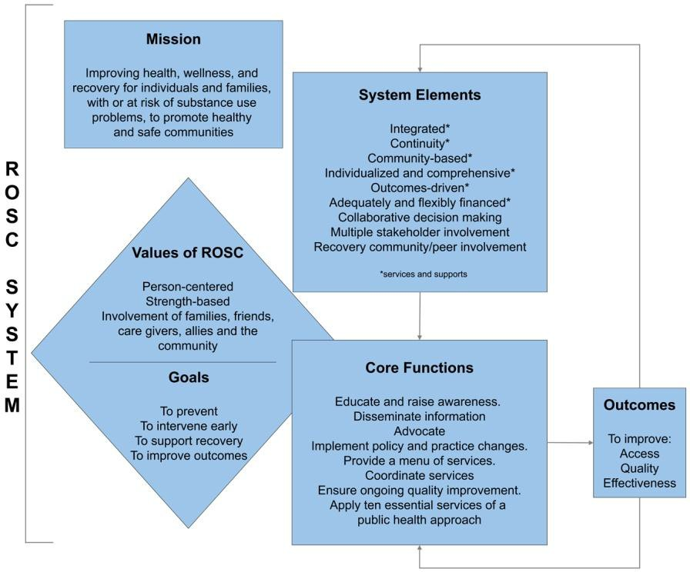
The diagram pictured illustrates a ROSC framework that includes the mission, values, goals, system elements, core functions, and outcomes of the systems. The principles of a ROSC and health care are closely aligned—for example, invest in prevention and wellness, expand coverage, guarantee choice, and improve quality of care. A major component
of a ROSC is implementing the provisions of health care reform to provide high-quality substance use services. To achieve reform, integration of substance use services will need to occur within primary care settings. Primary care providers will likely require additional education and training on how to screen and intervene with at-risk populations, and on how to refer individuals with more severe conditions to specialty settings. Additionally, specialty providers may be required to establish new partnerships, enhance technology, establish quality improvement systems, expand capacity, recruit and train staff, and work with health insurance plans.
The following websites will provide you with information on the ROSC framework and health care reform:

- Perspectives on Systems Transformation: How Visionary Leaders are Shifting Addiction Treatment Towards a Recovery-Oriented System of Care (ROSC) http://www.attcnetwork.org/regcenters/productdetails.asp?prodID=258&rcID=3
- Coalition for Whole Health: Summary of Recommendations for Including Mental Health and Substance Use Disorder Prevention, Treatment, Rehabilitation, and Recovery in Health Reform http://lac.org/doc_library/lac/publications/CWH--Healthcare_Reform_Recommendations-- summary.pdf
- The Effects of Health Care Reform on Access to, and Funding of, Substance Abuse Services in Maine, Massachusetts, and Vermont
http://www.nasadad.org/resource.php?base_id=2104

- Vermont Health Care Reform Legislation http://hcr.vermont.gov/legislation

History of ROSC
Implementation of ROSC continues to evolve today, and the passage of national health care reform has opened another potential door in support of ROSC. As more of the public responds to the integration of ROSC within the public health model, there will be additional lessons learned and further development of tools to enhance efforts and sustain health and human services systems at multiple levels.
Thus far, a number of factors at the Federal, State, and local levels have converged to initiate and support the development of ROSC. They include advances in research and technology, release of influential reports (i.e., the Institute of Medicine Quality Chasm Series), growth of the recovery community, an increased focus on collaboration and accountability, and implementation of successful local, State and Federal initiatives. In 2005, key policy makers, prevention and treatment professionals, families impacted by substance use disorders, persons in recovery, and Federal, State, and local officials were brought together at SAMHSA’s Center for Substance Abuse Treatment (CSAT) National Summit on Recovery. Their charge was to:
  - Develop ideas to transform policy, services, and systems that provide a recovery- oriented response for family members, as well as the persons seeking recovery.
  - Articulate guiding principles and measures of recovery that are adaptable across services and programs while supporting system improvements, data sharing, and program coordination.
  - Generate ideas that advance ROSC in multiple settings and systems, and for specific populations.
Participants successfully reached a consensus on the guiding principles of recovery and elements of recovery-oriented systems of care. This effort provided the framework for additional discussions and engagement by persons in communities across the country.
Opportunities for ROSC abound, as systems are integrated and transformed through coordination, communication, and linkage. SAMHSA and the substance use disorder field have begun to conceptualize the magnitude of this paradigm shift. The history of ROSC continues to be written as the focus of health care reform broadly encompasses the continuum of care for substance use disorders.
In order to learn more about the guiding principles of recovery and the early conceptual work done to define the systems elements of a ROSC, refer to the following website:
- National Summit on Recovery: Conference Report
http://pfr.samhsa.gov/ Enter ‚National Summit on Recovery‛ in the Search bar.

Additional resources associated with the history of ROSC, including reports, research briefs, monographs, training manuals, and presentations can be found at:
- The Institute for Research, Education, and Training in Addictions (IRETA) http://www.ireta.org/

Recovery Support Services (RSS)
Each of the partners in a ROSC can play a role in the provision of recovery support services. When RSS are provided across the continuum of care, they support resiliency, open doors to service access and engagement, and support long-term recovery. Person-centered supports bolster successful individual and family outcomes.
Recovery support services are non-clinical services that assist individuals and families working towards recovery from substance use disorders. They incorporate a full range of social, legal, and other resources that facilitate recovery and wellness to reduce or eliminate environmental or personal barriers to recovery. RSS include social supports, linkage to and coordination among allied service providers, and other resources to improve quality of life for people in and seeking recovery and their families. RSS are provided by professionals and peers and are delivered through a variety of community and faith-based groups, treatment providers, and RSS providers. Provision of RSS is based upon the needs in a person’s individualized recovery plan.
While typically viewed as available post-treatment, recovery support services within the construct of ROSC can be offered before, during, or even in lieu of treatment. This approach and its supports are inclusive of pre-treatment, as well as promotion of resiliency in prevention and early or brief interventions. These are tenets that also form the basis of a public health model and are aligned with the principles of health care reform.

Child care and transportation are two of the most commonly recognized support services, but States and providers must leverage other systems to assemble a broader menu of resources as they implement ROSC. By looking across the entire continuum and addressing supports specific to the individual, ROSC can identify a myriad of
resources that may be used to foster recovery. Housing, life skills training, help with employment readiness, and legal consultation are examples of support that may be beyond what a ROSC currently provides, but which are often important to supporting recovery. Wellness checks, which support healthy lifestyles, are currently used in primary care settings for persons who have chronic conditions such as diabetes or heart disease. This same practice can be replicated for persons with substance use disorders.


In addition to tangible resources like housing and transportation, there is a human element that is equally valuable in the provision of RSS. A peer mentor or recovery coach can be very effective in providing motivation and support as an individual seeks a recovery lifestyle.
When an established frame of reference reflects their own recovery process, peer mentors and recovery coaches are valuable assets in recovery support. They can bring significant interpersonal skills to their work with individuals engaged in or contemplating recovery. As a ROSC moves further into the implementation phase, peer-driven supports will become a part of the fabric of recovery that cannot be replicated by other resources.
Beyond the RSS functions that often require certification, States will be challenged to develop core competencies or minimal guidelines for persons and organizations who deliver these services.
Although health care reform and parity legislation will enable some service billing through insurance carriers for RSS, they may have more-stringent requirements related to service delivery for RSS than for conventional medical treatment. When peer-driven services are initiated, consideration should be given to a reasonable match of gender, education, ethnicity and recovery philosophy, as well as defined core competencies.
As a ROSC implements RSS, a few key steps can guide the process:

  - Secure a broad range of supports through leverage with all partner systems.
  - Focus on the specific needs of the individuals and families.
  - Engage peer recovery coaches who have a personal recovery focus.
  - Define competency guidelines. (Competency guidelines should reflect requirements of third- party insurance carriers if possible.)
Resources found below can assist States and providers to achieve these steps.

- An RCSP Conference Report: Emerging Peer Recovery Support Services and Indicators of Quality
http://www.facesandvoicesofrecovery.org/pdf/Publications/2006-09_RCSP_Report.pdf

- Ethical Guidelines for the Delivery of Peer-based Recovery Support Services
https://www.naadac.org/assets/1959/whitew2007_the_pro-act_ethics_workgroup.pdf
- Manual for Recovery Coaching and Personal Recovery Plan
http://www.bhrm.org Select ‚Clinical Guidelines‛; select ‚Addiction Guidelines; scroll down to ‚Recovery Coach and Recovery Planning Manual
- Center for Substance Abuse Treatment: What are Peer Recovery Support Services http://store.samhsa.gov/product/SMA09-4454
- Recovery Coach Training Manual http://www.nattc.org/resPubs/changeBook.html
- Financing Recovery Support Services: Review and Analysis of Funding Recovery Support Services and Policy Recommendations https://www.samhsa.gov/sites/default/files/partnersforrecovery/docs/RSS_financing_report.pdf
- Vermont Substance Abuse Recovery - provides access to the Recovery Centers Website; Friends of Recovery-Vermont (consumer/advocacy network); and the Vermont Peer Resources Guide
http://healthvermont.gov/adap/recovery/Recovery.aspx

Role of Recovery Management
Within the framework of a ROSC, recovery management provides treatment and recovery supports to individuals with severe substance use disorders. This targeted approach to a specific population differs from the overarching role of a ROSC. As has been described, a ROSC serves those with or at risk for substance use problems. The persons served within a ROSC encompass the general population, at-risk populations, harmful users of alcohol and drugs, those with dependence, and those with chronic dependence.
Recovery management is often described as typifying the shift from an acute care model, which treats medical conditions in an intensive short-term manner, to a chronic care approach reflecting a service commitment to long-term supports and wellness. A ROSC provides a full spectrum of services based on individual need. These may include early intervention service (i.e., Screening, Brief Intervention and Referral to Treatment), acute care services (i.e., medically managed detoxification), and chronic care services (i.e., continuing care followed by recovery checkups, otherwise known as Recovery Management).

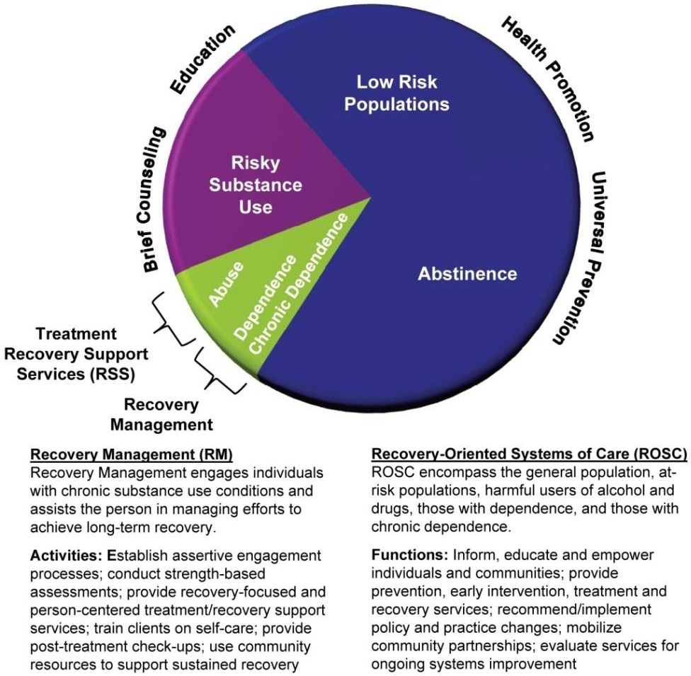

The public health community has long practiced recovery management when treating chronic diseases such as diabetes, asthma, and hypertension. While public health care providers may use different terminology, recovery management is a tool embedded in their approach to practice.
Public health principles address health promotion through comprehensive prevention strategies, screening, early intervention, treatment, and reinforcement of healthy lifestyles. Sound familiar? This model is also found in ROSC, and one that is the cornerstone of the new health care environment.
Recovery management engages individuals with chronic substance use conditions and assists the person in managing efforts to achieve long-term recovery. Individuals and their families are empowered to seek supports specific to meet the needs of the person. There is no formula or set of rote practices that serve everyone. Different persons require different resources. It is the role of recovery management to coordinate access to resources and foster engagement. ROSC coordinate the layers of multiple systems that can produce those resources. As a result of the collaborative work done by a ROSC, these systems—including criminal justice, education, child welfare, and primary care—can provide the supports necessary to sustain recovery management activities.
To learn more about the role of recovery management within ROSC, please access the following websites:
- Implementing Recovery Management Part 1: The Organizing Concept http://www.attcnetwork.org/learn/topics/rosc/docs/AddicMsgVol.11,Issue4NEW.pdf
- Implementing Recovery Management Part 2: Making the Philosophical Shift http://www.attcnetwork.org/userfiles/file/Vol.%2011,%20Issue%205%20NEW.pdf
- Frontline Implementation of Recovery Management Principles
http://www.williamwhitepapers.com/pr/Interview_With_Michael_Boyle%20Interview.pdf
- Recovery Management & Recovery-Oriented Systems of Care: Scientific Rationale & Promising Practices http://www.attcnetwork.org/REGCENTERS/generalContent.asp?rcid=3&content=STCUSTOM1
- Recovery Management in Communities of Color http://www.nattc.org/recoveryresourc/docs/RecMgmt.pdf
- Implementing Recovery Management Part 3: Recovery Coaching Pays Dividends http://www.nattc.org/userfiles/file/Vol.%2011,%20Issue%206%20NEW(1).pdf

What Is Happening Around the Country?
At the 2005 National Summit on Recovery, a recommendation was made to hold a series of regional meetings to assist States and communities in planning and implementing ROSC. Following the Summit’s recommendation, the Center for Substance Abuse Treatment’s (CSAT’s) Partners for Recovery (PFR) Initiative hosted five regional meetings in 2007 and early 2008 to support ROSC planning and implementation at the State and community levels. Teams from 49 States, the District of Columbia, and Puerto Rico participated.
At that time, the stages of ROSC implementation across the country ranged from active planning and systemic re-engineering to very preliminary consideration of the ROSC concept. Of those States attending the regional meetings, 10 percent (5 States) were engaged in active planning and implementation of ROSC, 35 percent (18 States) were implementing system elements and had begun planning for ROSC, 43 percent (22 States) had implemented one or more system elements, and 12 percent (6 States) were considering implementing ROSC.
As a part of the work done during the regional meetings, State teams were asked to envision a ROSC that reflected their own locale’s unique environment, inclusive of challenges and creative solutions to work within existing systems. They were then asked to develop an action plan to identify steps that have been taken, and what steps need to be taken to facilitate implementation of ROSC.
After the regional meetings, a number of States moved forward in implementing a recovery- oriented framework. These states have cultivated partnerships with the medical community, among other systems, and are poised to further implement the tenets of health care reform in their alcohol and drug programming. Following are examples of State ROSC activities:

California
In 2006, the California Department of Alcohol and Drug Programs (CADP) began a multi-year process to support system evolution from an acute care model to one of chronic care. Established by CADP, the Continuum of Services System Re-Engineering Task Force have led this effort through engagement of stakeholders, development of core principles and goals, and creation of a website containing their presentations, findings, and other materials that reflect the principles of ROSC. As with most States, resources have diminished, but California remains committed to supporting a client- centered chronic care system that is inclusive of prevention, treatment, and recovery.

North Carolina
A task force, convened at the direction of the North Carolina General Assembly and led by the North Carolina Institute of Medicine, has steered the State’s efforts to plan and implement ROSC. In addressing the full continuum of care, the task force published a comprehensive report that provided significant recommendations for a system redesign that reflects the principles of ROSC. Their work was taken a step further by the legislature when this model was embedded in State

statutes. Today, much of the activity centers around training and a public campaign called
‚Recovery North Carolina.‛ The campaign has successfully engaged an advisory board, as well as volunteers and community members throughout the State.
North Carolina also redirected funds through an RFP process to allow provider flexibility in establishing services to support ROSC. The challenges that remain in North Carolina are primarily lack of funding and lack of a data system to support the success of evidence-based practices.

Vermont
Prior to the regional meetings, Vermont had begun to construct a framework for recovery activities, called Friends of Recovery – VT. Following the CSAT-sponsored meetings, and with technical assistance from their ATTC, Vermont began to formalize ROSC through the establishment of a strategic plan and mission statement. The plan ensured that all stakeholders understood the principles and concept of ROSC. In addition, a State initiative, the Vermont Blueprint for Health, provided a statewide structure and a vehicle to more effectively manage chronic diseases using a public health model in tandem with ROSC. With the strategic plan, mission, and Friends of Recovery – VT in place, the State initiated a series of provider trainings with the assistance of NIATx. Incentives planning grants and monthly learning calls have further bolstered Vermont’s efforts to implement ROSC.
Steps have been taken to ensure that the prevention community is part of the overall continuum, and that a strong family focus and resiliency are integral to ROSC. Vermont has termed their systems change approach a Resiliency and Recovery-Oriented Systems of Care (RROSC). Vermont has instituted telephone recovery checkups, fostered peer support, and strengthened an integrated approach to RROSC.
The websites below will provide you with additional information on these and other initiatives that are underway across the country.
- National Summary of CSAT’s Regional Recovery Meetings https://www.samhsa.gov/sites/default/files/partnersforrecovery/docs/ summary_csat_regional_recovery_meetings.pdf
- A Recovery Revolution in Philadelphia
http://www.ireta.org Enter the title in the Search bar and press ‘Go.’

- Continuum of Services System Re-Engineering Report, September 24, 2008 http://www.adp.cahwnet.gov/COSSR
- Vermont Blueprint for Health http://hcr.vermont.gov/blueprint_for_health
- Building a Recovery-Oriented System of Care: A Report of the NCIOM Task Force on Substance Abuse Services, January, 2009.
http://www.nciom.org/wp- content/uploads/NCIOM/projects/substance_abuse/chapters/FullReport.pdf

The following three documents can be found at: http://pfr.samhsa.gov/rosc.html

  - Access to Recovery (ATR) Approaches to Recovery-Oriented Systems of Care: Three Case Studies
  - Provider Approaches to Recovery-Oriented Systems of Care: Four Case Studies
  - Approaches to Recovery-Oriented Systems of Care at the State and Local Levels: Three Case Studies

Planning and Implementation Steps
Creating a ROSC requires thoughtful and strategic planning, particularly as policymakers, providers, the recovery community, and the general public negotiate systems changes that involve the integration of substance use services within the general health care system. This evolution is ongoing, so be mindful of its implications as you plan and implement ROSC within your State or community. Identifying where you are in the ROSC planning and implementation process, while being cognizant of the new health care environment, will guide you in determining priorities and next steps.
The diagram below reflects the steps that are integral to establishing a systems change process. Each will be further described in this resource guide.

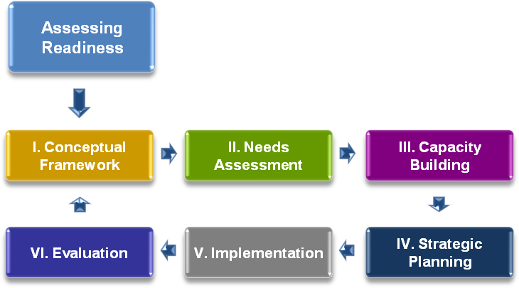

A Readiness Assessment should examine your willingness and ability to establish a platform for a ROSC. A coalition of stakeholders should be engaged to consider important questions that examine the level of commitment and feasibility for the effort. That dialogue may prompt divergent opinions before you reach a consensus. However, that is to be expected, given the time and effort needed to construct a functional ROSC. A facilitator with no vested interested in the outcome can play a key role in keeping the discussion moving and maintaining a record of the proceedings.

In assessing readiness, there are core questions that, when answered, will drive the consideration for systems change. The following table can be used to frame that discussion.

ASSESSING READINESS: Core Considerations in Preparing for Change

Initial Consideration | Further Considerations
1. Can you build a compelling case for change? | - What is the compelling case for creating a ROSC at this time?  - What problems will be solved?  - What value will be added to the system?  - What currently is being done in your community to address substance use problems and disorders?  - How effective are the current interventions?  - Will change be better than business as usual?
2. Are the anticipated results compelling enough to initiate and sustain the change process? | - What are the desired results from adopting a ROSC?  - Results for your community?  - Results for families and involved others?  - Results for persons in or seeking recovery?  - By when do you expect to see these results?  - What measures will you use to assess progress and impact?
3. Are the essential stakeholders willing and able to commit to and champion ROSC over time? | - Who will be the sponsors and advocates of a ROSC change initiative in your community?  - Are the sponsors able to initiate and sustain support for the process?
4. Are the potential benefits of change, and the consequences of "business as usual,‛ sufficient for community stakeholders to support ROSC implementation? | - What are the consequences of continuing systems as they currently exist?  - For the key stakeholders, what are the rewards associated with supporting and participating in the ROSC initiative?  - What are their incentives for sustained engagement?
5. Are there sufficient systems and resources in your community to support implementation of ROSC? | - How much will it cost to adopt a ROSC?  - Are stakeholders willing and able to assure the systems and resources necessary to fully sustain a ROSC over time?

You may also wish to use the resource below to further aid in the assessment process.

- Community Readiness Survey http://www.ncspfsig.org/Project_Docs/Community%20Readiness%20Survey2.doc

The next step in the assessment readiness process is to establish a Conceptual Framework. Use of focus groups and key participant interviews can ensure input from a broad spectrum of the community. Participation by persons in recovery, as well as family members and other allies, can provide valuable insights as stakeholders develop a vision for a system of care, clearly articulate values for how services should be delivered, and determine the desired outcomes for individuals, families and communities. Some of the questions posed to the stakeholder group during the assessment readiness exercise may help structure the conceptual framework. In addition, other important questions are:
  - What is your definition of recovery?
  - What should a ROSC look like in your community?
  - Why is a change needed?
  - What outcomes do you hope to achieve through a ROSC?
A discussion and consideration of these issues should result in a common vision, and in common values, system elements, outcomes, and definitions. Without general agreement on the conceptual framework for the ROSC, the process cannot successfully move forward. Below are additional resources to inform your dialogue when developing a conceptual framework.
- Connecticut Recovery Core Value http://www.ct.gov/dmhas/cwp/view.asp?a=2901&q=335078
- Overarching Tenets of the Recovery Initiative http://www.ct.gov/dmhas/LIB/dmhas/Recovery/tenets.pdf
- A Recovery Revolution in Philadelphia
http://www.ireta.org/ Enter the title in the Search bar and press ‘Go.’

Completion of a Needs Assessment is another key step in developing an informed ROSC plan. Stakeholders must understand the extent of substance use problems, the populations affected, gaps in services and supports, and services and systems that require quality improvements. This information will allow you to target and maximize resources. Identifying community and organizational strengths is equally important, as they provide a strong foundation upon which to build. This identification can strengthen discussion among ROSC partners, and provide a path for support in your implementation plan. Stakeholders should also examine policies and practices to assess their alignment with ROSC elements, in order to determine what changes are required to structure a functional ROSC.

- Assessment Primer: Analyzing the Community, Identifying Problems, and Setting Goals http://www.cadca.org/resources/detail/assessment-primer
- Yale Program for Community Health and Recovery: Recovery Self-Assessment (Provider Version)
https://medicine.yale.edu/psychiatry/prch/tools/

The needs assessment process has identified the strengths as well as gaps in services within the current systems. It should now be translated into a plan to enhance the capacity of your system where needed. Capacity Building is an integral part of successful systems change implementation. Does your ROSC have capacity at all levels, the staff or volunteer level, the organizational level, the broader systems level?
Each systems element should reflect a comprehensive, person-centered, and individualized approach to service provision. It is understandable that all systems may not initially align with this operational philosophy, but it’s important to determine what your capacity needs are so that they can be addressed. In addition to workforce capacity, technology and other resources should be considered. For further information on capacity building, see the resources below.
- Capacity Primer: Building Membership, Structure and Leadership http://www.cadca.org/files/CapacityPrimer-07-2009.pdf
- National Certified Recovery Specialist
http://www.iaodapca.org/credentialing/national-certified-recovery-specialist-ncrs/
- Maintaining Abstinence Program: A Curriculum for Families in Recovery https://vtrecoverynetwork.org/data/Recovery_Symposium/MAPSFamiliesinRecovery-%20Stages% 20of%20Recovery%20(2).pdf
- Pennsylvania OMHSAS: Strategies for Promoting Recovery and Resilience and Implementing Evidence-Based Practices
http://www.cmsu.org/recoverydocument.pdf

- Executive Leadership Guidelines for Developing a Behavioral Electronic Health Record System Technology Plan http://www.ndiic.com/documents/Developing%20an%20Electronic%20BH%20Tech%20Plan
%2001-27-2010.pdf

- State HIE Resources http://statehieresources.org/state-plans/

The next step in ROSC planning and implementation is development of a Strategic Planning Process. After you have assembled a planning team that represents stakeholder interests, articulated a vision, conducted a needs assessment, and constructed a capacity building plan, it’s time to develop a strategic plan including specific ROSC goals. A critical step at this juncture is,

once again, to ensure sufficient community representation, inclusive of individuals in recovery, family members and other allies.
Following that, the planning team should be charged with identifying measureable objectives for each goal, as well as strategies to support achievement of each goal. Other tasks that should be completed in order to reinforce a strategic planning process are:
  - Developing action steps,
  - Identifying timelines and parties responsible for completing each strategy,
  - Creating a resource plan, and
  - Documenting the entire plan.
To guide you further during the strategic planning process, refer to the information below.

- Planning Primer: Developing a Theory of Change, Logic Models, and Strategic Action Plans https://www.cadca.org/resources/planning-primer-developing-theory-change-logic-models-and- strategic-and-action-plans
- Creating a Strategic Plan http://www.ncspfsig.org/Project_Docs/Creating%20A%20Strategic%20Plan_How%20To%20G uide.pdf
- Getting to Outcomes: 10 Steps for Achieving Results-based Accountability http://www.rand.org/pubs/technical_reports/2007/RAND_TR101.2.pdf
- Getting to Outcomes 2004: Promoting Accountability Through Methods and Tools for Planning, Implementation, and Evaluation http://www.rand.org/pubs/technical_reports/2004/RAND_TR101.pdf

Now that the planning is well underway, it’s time to begin assembling the resources for Implementation. Engagement of the community at large, as well as individuals in recovery, their families, and other allied members, will strengthen efforts to identify and garner resources for a ROSC. Implementation of ROSC will require changes to a number of institutional practices and processes. Trying to affect change in multiple levels of systems that interact with other multiple levels of systems can be overwhelming. You may initially focus on workforce development, financing, policy enhancement, technology changes to support data tracking and billing, or one of many other topics that will come into play when putting your plan into practice. Due to the complexity and challenges inherent in a major systems change, it may be wise to implement ROSC incrementally.
To further inform your implementation efforts, see the resources listed below.

- Implementation Primer: Putting Your Plan into Action http://www.cadca.org/resources/detail/implementation-primer
- Implementing a Statewide Recovery-Oriented System of Care: From Concept to Reality http://www.ct.gov/dmhas/LIB/dmhas/presentations/2.6.05.pdf

- Connecticut Department of Mental Health and Addiction Services: Proposed Model of Mental Health Recovery and Recovery-Oriented Services: http://www.ct.gov/dmhas/lib/dmhas/recovery/mhmodel.pdf
- Cultural Competence Primer: Incorporating Cultural Competence into Your Comprehensive Plan
https://www.cadca.org/resources/cultural-competence-primer-incorporating-cultural-competence-
your-comprehensive-plan
- Connecticut DMHAS. Practice Guidelines for Recovery-Oriented Care for Mental Health and
Substance Use Conditions http://www.ct.gov/dmhas/lib/dmhas/recovery/practiceguidelines2.pdf
- Connecticut Implementation of Person-Centered Care
http://www.ct.gov/dmhas/LIB/dmhas/Recovery/personcentered.pdf

- California Access to Recovery (CARE) Recovery Support Services Screening and Assessment Tool http://www.californiacares4youth.com/downloads/RSS%20screening%20and%20assessment% 20tool.pdf
- Practice Guidelines for Recovery-Oriented Behavioral Health Care http://www.ct.gov/dmhas/LIB/dmhas/publications/practiceguidelines.pdf
- Recovery Advocacy Toolkit: Resource Guide http://www.facesandvoicesofrecovery.org/publications/advocacy_toolkit/resources.php
- Peer/Recovery Support Specialists within Behavioral Health Agencies: Desktop Guide http://www.azdhs.gov/bhs/guidance/peer.pdf


As States and communities move toward implementation of ROSC, Financing may become a primary concern. However, broad consideration must be given to all viable funding sources to encourage creative and flexible financing. An initial review of funding resources may focus on Medicaid and the Substance Abuse Prevention and Treatment Block Grant (SAPT BG), but other streams may be leveraged when States are able to braid dollars and access funding from multiple systems. There is great diversity
across the country regarding financing of systems of care, and there is not one funding solution that will adequately meet the needs of every community. The key is sufficient flexibility to achieve the best outcomes for individuals, families, and communities.

Flexible funding will enable a ROSC to offer individualized and comprehensive services for each person in a manner that best meets their needs. Funding tied to specific program models and approaches that are ‚one size fits all‛ is inconsistent with the person-centered focus of a ROSC. A ROSC that exercises creative financing strategies to offer an array of services tailored to an individual’s needs will encourage more successful outcomes. Offering financial incentives to offset systems improvement costs and providing start-up funds to initiate systems change are successful strategies that have been used in States and localities.
While States have historically relied on Medicaid, the SAPT BG, and State general revenue dollars to fund prevention, treatment, and recovery services, those who are planning and implementing ROSC are also accessing resources provided through other systems. Changes resulting from implementation of parity and national health care reform initiatives will open additional doors to service provision.
Some States have already forged a successful collaboration with the justice system, at both the local and Federal levels, to garner funding support for ROSC services. The education community and its prevention resources provide another avenue to enhance ROSC activities and funding.
Local environmental strategies shape school prevention initiatives that are broadly supported and funded.
Partnering with school systems ensures the inclusion of prevention as a part of ROSC. Seeking support and building a ROSC framework with multiple partners will bolster resources to sustain the most comprehensive system.
Financing opportunities may also be available from the private sector. As systems collaborate and identify common goals and activities supporting ROSC on a local level, foundation grants and private partner donations can be accessed to fund specific services. This can be achieved by designing a flexible system that satisfies the requirements of the funder while meeting the specific needs of individuals and families.
Another source of financing ROSC changes may be through Federal grant opportunities. An ROSC may secure ‚seed money‛ through grant awards to begin or further progress its systems changes.
Once those innovations are realized, cost offsets from the previous system structure may be realized and applied to the ROSC operation.
As you review the resources below, keep in mind that flexible financing can better position your ROSC to meet the unique needs of persons or families seeking services.
- Financing Recovery Support Services: Review and Analysis of Funding Recovery Support Services and Policy Recommendations https://www.samhsa.gov/sites/default/files/partnersforrecovery/docs/RSS_financing_report.pdf
- The Effects of Health Care Reform on Access to and Funding of Substance Abuse Services in Maine, Massachusetts, and Vermont http://nasadad.org/resources/Final%20revisions%20HCR%20508%20compliant.pdf

- Sustainability Primer: Fostering Long-Term Change to Create Drug-Free Communities http://www.cadca.org/resources/detail/sustainability-primer
- CMS Letter to State Medicaid Directors on Funding Peer Support Services http://www.cms.hhs.gov/SMDL/downloads/SMD081507A.pdf
- Virginia Recovery Support Demonstration Model http://www.dbhds.virginia.gov/SASC/documents/VARecoverySupportModelRFP.pdf
- Improving Public Addiction Treatment through Performance Contracting: The Delaware Experiment
http://www.ncbi.nlm.nih.gov/pmc/articles/PMC2736056/

- Connecticut DMHAS General Assistance Recovery Support Program (GA RSP) http://www.ct.gov/dmhas/cwp/view.asp?a=2900&q=334750

Having the necessary Policies and Regulations in place is critical to successful implementation of a ROSC. A thorough inventory of existing policies and regulations will determine which require amendment or modification. This process should also include identification and subsequent development of new policies and regulations that further support the framework for ROSC implementation and ongoing operation. A successful ROSC is made up of multiple stakeholders, representing multiple systems. Thus, the inventory must include a broad range of policies and regulations. These policies exist at the State level and local provider level, and will further unfold at the Federal level as national health care reform is realized.
Within the inventory will be State statutes. Significant changes may be required at the State level to ensure that enabling legislation is in place that reflects the fundamentals of ROSC. In addition to statutes related to the functions of the Single State Agencies (SSA) for Alcohol and other Drugs, language embedded in criminal justice statutes, primary health care statutes and child welfare may require amendment. Following statutory changes, States will develop or amend their Administrative Rules, and issue policy guidelines and interpretations to reflect ROSC fundamentals. Providers and other ROSC partners must also incorporate ROSC-related policies and procedures into their operational directives at the local level.
In order to fund a portion of ROSC services through Medicaid, State Medicaid Plans may require amendment and approval by the Federal Centers for Medicare and Medicaid Services. As national health care reforms crystallize, additional policies and regulations will need to be developed at multiple levels within a ROSC.
The breadth in policy and regulatory changes required to implement a ROSC may seem daunting. But once again, an incremental approach and prioritization of steps to implementation will enable States and providers to move forward in establishing a comprehensive ROSC.
Below are resources to assist States and providers in developing guidelines, policies, and procedures to structure a ROSC.

- Policy Statement #33 - Individualized Recovery Planning http://www.ct.gov/dmhas/cwp/view.asp?a=2907&q=334664
- Michigan DCHODCP Treatment Policy No. 08: Substance Abuse Case Management Program Requirements http://www.michigan.gov/documents/mdch/TA_Treatment_03_Case_Management_Services_17 5208_7.doc
- Michigan DCHODCP Treatment Technical Advisory No. 07: Peer Recovery/Recovery Support Services
http://www.michigan.gov/documents/mdch/TA-T-07_Peer_Recovery- Recovery_Support_230852_7.pdf
- OMHAS Resilience and Recovery Policy Statement http://www.oregon.gov/DHS/addiction/publications/recovery-resil-policy.pdf

Evaluation is integral to a systems change process. It can promote sustainability of effective policies, programs, and practices. It can inform funding decisions, guide clinicians and other service providers when they are working with patients, assist in patient decision making, and educate peers. Evaluation approaches typically look at the processes as well as the outcomes, ranging from short- to long-term goals and objectives.
As component partners within a ROSC begin to forge their resources through collaboration, it is important to consider data collection. Without a mechanism to collect administrative data, it may be difficult to make assumptions concerning performance improvements. Surveys, focus groups, and key informant interviews are also evaluation tools that can be used to strengthen evaluation findings. Stakeholder partners should be encouraged to provide input into the development of these tools in order to increase commitment, broaden their knowledge of the process, and increase the practicality of the evaluation findings. Through ongoing data collection and establishing performance measures you can capture meaningful and immediate response to your ROSC transformation activities.
An effective evaluation systemically tells us:

  - How well does the planning process reflect the identified needs, priorities and resources?
  - What is implemented—what programs, strategies, activities—and by whom?
  - What can we say about ‚implementation fidelity‛?
  - What changes were made along the way and why?
  - Where are the successes?
  - Where are needed improvements?
Thus far, little evaluation has been conducted on ROSC. This dearth of information highlights the importance of evaluating your recovery-oriented system to improvement them and to more effectively serve your community. Process improvement models are valuable resources to assist

you with enhancing your change processes and outcomes. They offer practical approaches to guide and test your work in real-life settings for the purpose of continuous quality improvement.
For information pertaining to evaluation activity, see the resources below.

- Institute for Healthcare Improvement: http://www.ihi.org/IHI/Topics/Improvement/ImprovementMethods/HowToImprove/
- The Network for the Improvement of Addiction Treatment (NIATx): http://www.niatx.net/Content/ContentPage.aspx?PNID=1&NID=7
- CDC Framework for Program Evaluation: http://www.cdc.gov/eval/framework.htm
- Connecticut DMHAS Recovery Self-Assessment: Executive Summary: http://www.ct.gov/dmhas/lib/dmhas/recovery/rsasummary.pdf

Additional ROSC Resources
- Is Your Drug Court Fit for Recovery? A Recovery Check-up http://www.facesandvoicesofrecovery.org/pdf/drug_court_check_list.pdf
- A Conceptual Bridge Between the Mental Health and Addiction Fields http://www.williamwhitepapers.com/pr/2006SystemsTransformation.pdf
- The Recovery Revolution: Will it include children, adolescents, and transition age youth http://www.facesandvoicesofrecovery.org/pdf/White/ChildAdolescents.pdf
- CDC. Principles of Community Engagement
https://www.atsdr.cdc.gov/communityengagement/
- Guiding Principles and Elements of Recovery-Oriented Systems: What do we know from the research?
https://www.naadac.org/assets/2416/
sheedyckwhitterm2009_guiding_principles_and_elements.pdf

Additional Health Care Reform Resources
- Kaiser Daily Health Policy Daily Reports http://www.kaiserhealthnews.org/Topics/Reform.aspx
- US Department of Health and Human Services, Substance Abuse and Mental Health Services Administration (SAMHSA)
Health System Reform: A Framework for Discussion http://www.samhsa.gov/Healthreform/index.aspx
- Trust for America’s Health: Prevention and Wellness in Health Care Reform resources
https://www.tfah.org/about/
- National Health Care Reform http://lac.org/
- Benefit Design and the Delivery of Care (equitable & full coverage; access) http://lac.org/doc_library/lac/publications/CWH-- Benefit_Design_and_the_Delivery%20of_Care.pdf
- Reforming the Health Care Delivery System (workforce development, training all health professionals in MH and SA issues, medical home model, ensuring that MH & SA professionals are included and prioritized in any broader workforce development efforts) http://lac.org/doc_library/lac/publications/CWH-- Reforming_the_Healthcare_Delivery_System.pdf

- Wellness Promotion and Chronic Disease Prevention Initiatives http://lac.org/doc_library/lac/publications/CWH-- Wellness%20Promotion_and% 20_Chronic_Disease_Prevention_Initiatives.pdf
- Reports of Interest http://www.acmha.org/reports_of_interest.shtml

Summary
The information and materials provided in this guide will continue to be updated and disseminated for use as the movement to ROSC and national health care solidifies policies and provides further guidance to stakeholders, providers, and policymakers vested in the substance use disorders field. As this evolution occurs, you may be just beginning to conceptualize ROSC for your community, while others are tackling implementation issues and beyond. Regardless of your stage in the planning and implementation process of ROSC, please use this resource guide as a tool to encourage discussion and strengthen the infrastructure of ROSC in your community.
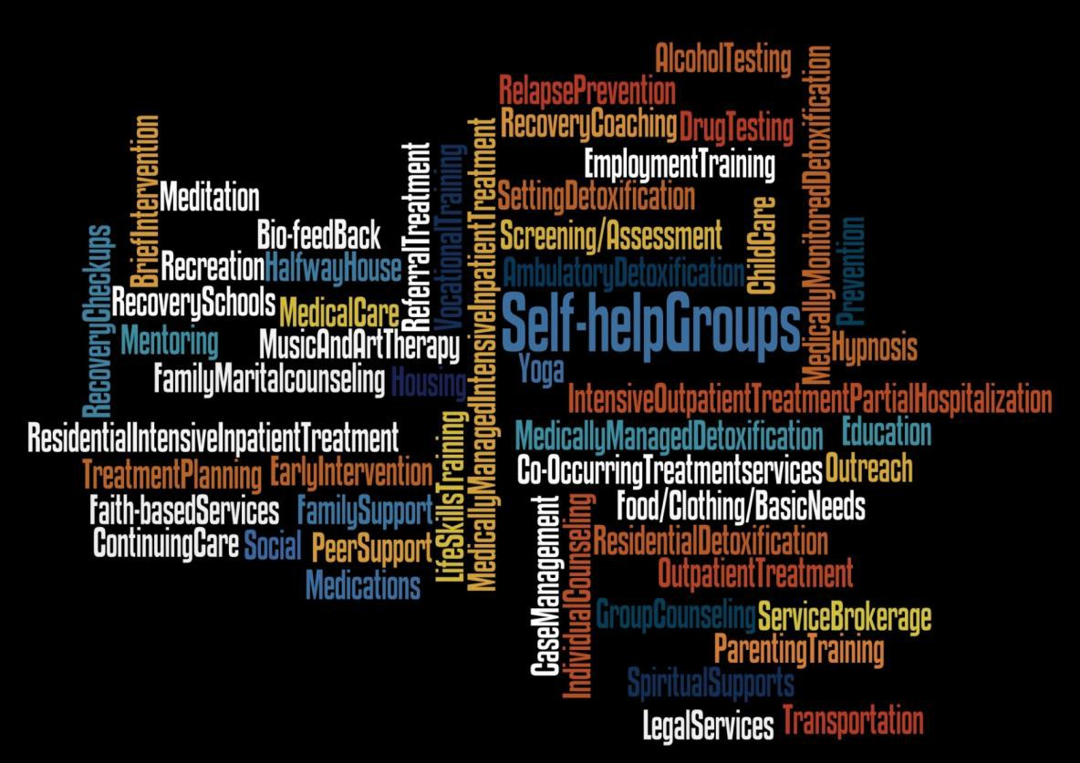

Acknowledgement

This technical assistance resource guide was prepared for the Substance Abuse and Mental Health Services Administration’s (SAMHSA’s) Partners for Recovery (PFR) Initiative by Melanie Whitter and Donna J. Hillman of Abt Associates Inc. and Peggie Powers, consultant to Abt Associates Inc. Shannon B. Taitt, M.P.A., served as the Government Project Officer.

Disclaimer

The views, opinions, and content of this publication are those of the authors and do not necessarily reflect the views, opinions, or policies of the Substance Abuse and Mental Health Services Administration/Center for Substance Abuse Treatment (SAMHSA/CSAT).

